

KS-05 | DOCUMENT CONTROL  Parent Formation and Family Care workstream

Field | Controlled value
Program | KUTUMBA — Families Growing in Krishna Consciousness
Document | Parent Formation and Family Care Operating Model
Document code | KS-05
Version | 1.0
Issue date | 29 June 2026
Status | Working reference for review and controlled implementation
Primary users | Program Director; Curriculum Lead; Parent Facilitators; Mentor Families; Care/Safety Lead
Review cycle | At the end of each active cycle during pilot; annually after stabilization
Source of truth | Controlled KUTUMBA repository; approved family-facing copy published separately
MANDATORY PRE-LAUNCH CONDITION
Before families are enrolled, the child-protection, reporting, clearance, crisis, confidentiality, and referral sections must be reviewed against current Pennsylvania law, current ISKCON child-protection policy, local temple requirements, insurance conditions, and the actual venue. This report is an operating framework, not legal advice.

Purpose of this document
This document converts KUTUMBA’s parent-track vision into an implementable system. It defines what adults learn, how sessions work, how household practice is supported, what mentors may and may not do, how confidential matters are handled, how progress is reviewed, and how the work remains within devotional and educational boundaries.
It is designed for a small founding cohort of approximately five to six families, normally ten to twelve adults, meeting on Friday evenings within the wider KUTUMBA program. The model can scale, but it deliberately avoids bureaucracy that would delay a safe pilot.

Executive decisions
Decision | Operating consequence
Outcome, not attendance | The parent track measures changed household practice, relational conduct, and reliability—not mere presence, eloquence, disclosure, or devotional appearance.
Application-led teaching | Each lesson moves from a real family tension to śāstra, reflection, rehearsal, one household commitment, and review.
Small commitments | Families use observable, time-bounded saṅkalpas with a fallback version. Failed weeks trigger redesign, not shame.
No compelled disclosure | Adults may pass. Written or anonymous reflection is valid. Emotional intensity is not treated as evidence of growth.
Education, not treatment | KUTUMBA does not provide therapy, medical care, legal advice, addiction treatment, or marital adjudication.
Controlled care | Sensitive issues move from the group to a designated care or safety pathway. Immediate safety overrides ordinary confidentiality.
Mentors have limits | Mentors support routines and participation; they do not become spiritual controllers, therapists, investigators, lenders, or secret allies.
One system for adults and children | Parents study the same central theme as children and model the practices children are being asked to learn.
Progressive commitment | Advancement is gradual and private. Completion does not confer teaching authority, initiation eligibility, or automatic leadership.
Review before scale | The founding pilot is evaluated after every active cycle before enrollment or service responsibilities expand.

How to use the report
Audience | Primary use
Program Director | Approve boundaries, staffing, escalation routes, launch gates, and review decisions.
Curriculum Lead | Use the learning architecture, source controls, session schema, and quality checklist when producing adult lessons.
Parent Facilitator | Follow the 20-minute and 40-minute methods; protect time, agency, confidentiality, and application.
Mentor Family | Use the check-in, accountability, and referral rules without exceeding role boundaries.
Care/Safety Lead | Own the current referral directory, reporting procedure, documentation controls, and urgent escalation.
Participating Family | Use the household planners, media agreement, saṅkalpa card, and cycle review privately.

Research and authority hierarchy
The framework uses a controlled hierarchy so that educational research can improve method without overruling devotional authority, and devotional enthusiasm cannot override law or safeguarding.
Priority | Authority and use
1. Law and immediate safety | Applicable civil law, emergency response, mandatory/permissive reporting, and venue safety requirements.
2. Current ISKCON policy | Current child-protection, safeguarding, worship, temple, and governance requirements.
3. Śrīla Prabhupāda’s books | Primary philosophical and devotional source for KUTUMBA lessons and household application.
4. Approved KUTUMBA governance | Charter, covenant, decision rights, source policy, confidentiality policy, and approved curriculum architecture.
5. Evidence-informed methods | Active learning, behavior planning, positive discipline, media guidance, and psychologically safe facilitation.
6. Facilitator adaptation | Examples, pacing, and activities may be adjusted; philosophy, safety controls, and learning outcomes may not be improvised.
SOURCE CONTROL PRINCIPLE
A useful parenting technique is not automatically a KUTUMBA standard. It must fit the devotional source hierarchy, remain within educational boundaries, and pass safeguarding review.

Contents at a glance
Section | Coverage
Part I | Charter, authority, boundaries, failure modes
Part II | Adult learning, Prem-kī-Kathā, guided discussion, case method
Part III | Parent-child bonding, modeling, speech, parenting, marriage, routines, chanting, offerings, media
Part IV | Confidential care, mentor families, accountability, resistant-parent engagement
Part V | Commitment pathway, assessment, three-year progression, first six-month overlay
Part VI | Staffing, training, launch gates, quality control, privacy, pilot review
Appendices A–O | Ready-to-use templates, cards, checklists, referral sheet, source register

PART I | CHARTER, AUTHORITY AND BOUNDARIES  What the parent track is for—and what it must never become

1. Parent-track charter
The parent track forms adults who can understand Kṛṣṇa conscious principles, apply them in ordinary household life, and create a safe devotional culture in which children observe their parents learning, chanting, serving, apologizing, regulating speech, and accepting correction.

1.1 Purpose
- Help adults understand foundational Kṛṣṇa conscious principles in language connected to real family responsibilities.
- Build realistic personal and family devotional routines that can survive work pressure, school schedules, illness, travel, and imperfect motivation.
- Train communication, anger regulation, confidentiality, correction, apology, repair, and cooperation as learnable devotional practices.
- Help parents model the conduct they expect from children rather than outsourcing spiritual formation to a weekly class.
- Provide graduated support through facilitators, mentor families, and private review while preserving adult agency.
- Prepare families for stronger temple participation, service, deeper study, and—where appropriate—authorized future pathways such as Bhakti Śāstrī and initiation processes.
- Protect the program from gossip, spiritual coercion, emotional performance, amateur counseling, and unmanaged safeguarding risk.

1.2 Completion profile
A parent completing the three-year pathway should increasingly be able to:
- explain foundational philosophy without speculation;
- maintain a meaningful personal practice and a realistic family devotional anchor;
- offer food, read, chant, attend festivals, and serve with increasing steadiness;
- communicate truthfully and beneficially without normalizing agitation, contempt, gossip, or public humiliation;
- correct children calmly, proportionately, privately when possible, and with a clear path to repair;
- cooperate with a spouse or co-parent without using scripture, leaders, or children as leverage;
- recognize when a problem exceeds KUTUMBA’s role and use an appropriate referral pathway;
- participate reliably in service without neglecting health, livelihood, children, or essential household obligations;
- support newer families without controlling them.
READINESS, NOT ENTITLEMENT
Three-year completion does not automatically qualify anyone to teach, mentor, lead worship, receive initiation, or make recommendations about another family. Those decisions remain with the relevant authorized process.

2. Alignment with the KUTUMBA Master Operating Model
This parent model is not a separate program. It operates inside the approved KUTUMBA identity, six charter purposes, three-year curriculum, forty-active-week rhythm, Friday session structure, KUTUMBA Setu newcomer pathway, service roster, governance, and digital controls.

2.1 Friday integration
Time | Program element | Parent-formation function
6:15–6:30 | Arrival and setup | Parents model punctuality, bhoga handoff, phone discipline, welcome, and calm transitions.
6:30–7:00 | Kīrtana and worship | Adults participate rather than supervise from the edge; one short etiquette reminder only.
7:00–7:20 | Prem-kī-Kathā | A single family-life tension is connected to one scriptural principle and one application.
7:20–8:00 | Parallel formation | Parents and children study the same central theme through age-appropriate methods.
8:00–8:20 | Bhakti laboratory | Families rehearse a practical devotional skill together.
8:20–8:30 | Family saṅkalpa | Each family selects one realistic household practice.
8:30–9:00 | Prasāda | Adults model prayer, serving order, gratitude, conversation, child supervision, and timely closure.

2.2 Decision rights
Role | Decision right / limit
Program Director | Approves launch, staffing, major policy, suspension, and external escalation protocol.
Curriculum/Philosophy Lead | Approves sources, learning outcomes, facilitator guides, and philosophical correction.
Parent-Track Lead | Owns lesson delivery, facilitator calibration, attendance interpretation, and cycle review.
Children/Safety Lead | Has independent authority to stop an unsafe activity and activate safeguarding procedures.
Care Contact | Receives sensitive adult concerns, limits information, and routes referrals within role.
Mentor Family | Supports application and onboarding; does not decide policy or investigate concerns.
Facilitator | May adapt examples and timing; may not alter philosophy, disclosures, safety controls, or required outcomes.
Participating Adult | Chooses personal disclosure and a realistic practice; must still follow covenant and safety rules.

3. Educational and care boundaries
The parent track must be useful enough to change behavior but narrow enough to remain safe. The correct boundary is education, formation, ordinary support, and referral—not diagnosis, adjudication, or treatment.

3.1 What KUTUMBA may teach
- devotional communication and speech discipline;
- anger interruption and ordinary emotional self-regulation;
- clear requests, listening, apology, repair, and household planning;
- parenting skills, positive correction, routines, media agreements, and family meetings;
- home chanting, reading, food offering, service, worship preparation, and festival participation;
- scriptural principles concerning responsibility, cooperation, simplicity, regulation, and devotional household life;
- how to identify a concern, protect privacy, and seek qualified support.

3.2 What KUTUMBA may not do
- decide which spouse is right or pressure reconciliation, separation, or obedience;
- investigate abuse, trauma, infidelity, addiction, criminal behavior, or child-protection allegations;
- diagnose mental-health, developmental, medical, or learning conditions;
- provide psychotherapy, addiction treatment, legal advice, financial advice, or medical treatment;
- promise that devotional practice alone will resolve a clinical, legal, or safety problem;
- compel disclosure, demand confession, or interpret tears, silence, reluctance, or doubt;
- use guru, śāstra, initiation, children, service, or community standing as leverage;
- circulate confidential information as “care,” “warning,” or “prayer request.”
“Austerity of speech consists in speaking words that are truthful, pleasing, beneficial, and not agitating to others.”
Bhagavad-gītā As It Is 17.15 — short guiding excerpt
Primary devotional anchors used in this model include Bhagavad-gītā 3.21, 6.17, 9.27, and 17.15; Nectar of Instruction 1 and 4; relevant household-life teachings in Śrīmad-Bhāgavatam; and the approved KUTUMBA source hierarchy.

3.3 Immediate referral triggers
- current danger, violence, stalking, coercive control, threats, weapon access, or fear of going home;
- suspected child abuse, neglect, sexual abuse, exploitation, grooming, or unsafe adult-child conduct;
- suicidal thoughts, self-harm, threats to harm others, severe disorientation, or acute psychiatric crisis;
- serious addiction, overdose risk, withdrawal danger, or intoxication that threatens safety;
- medical emergency or a condition requiring clinical evaluation;
- criminal, immigration, custody, financial, or legal issues requiring licensed advice;
- a facilitator or mentor conflict of interest, boundary breach, retaliation, or misuse of confidential information.
DO NOT INVESTIGATE
When safety or reportable harm may be involved, KUTUMBA leaders preserve immediate safety, record observable facts, and contact the approved authority or professional. They do not interview witnesses, test credibility, negotiate silence, or conduct an internal fact-finding process.

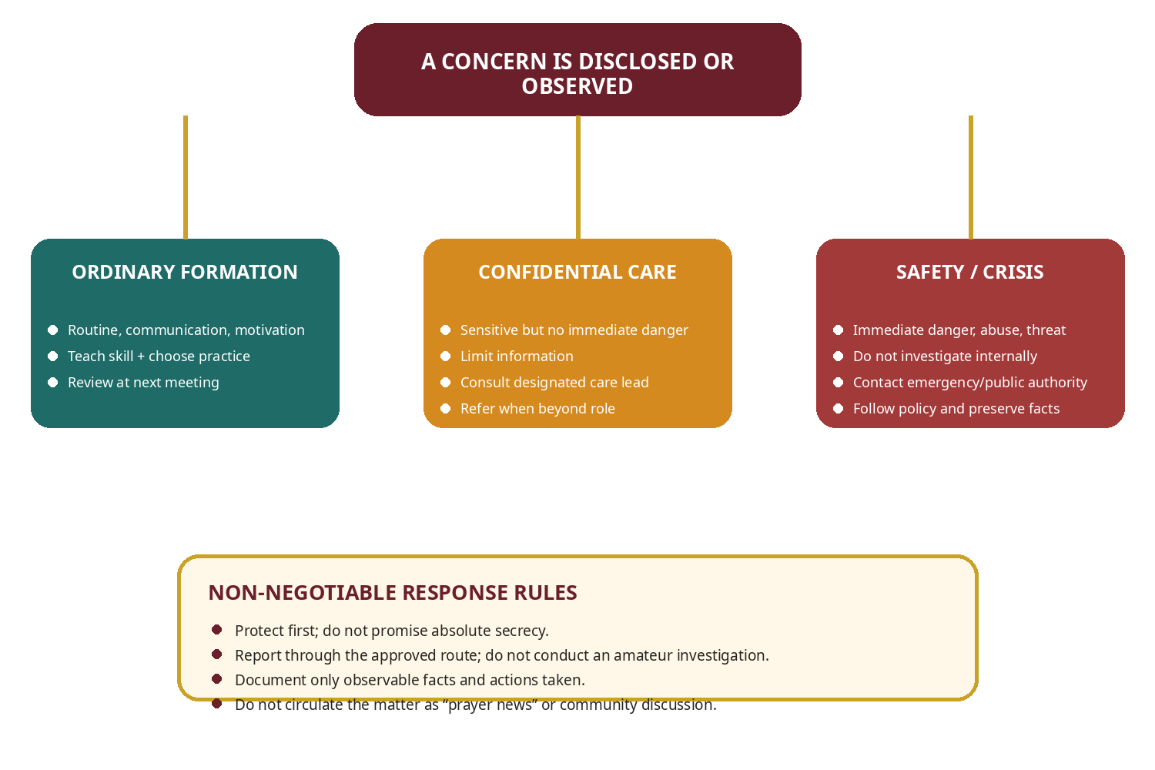
Figure 1. Educational support, confidential care, and safety/crisis pathways

3.4 Pennsylvania and ISKCON safeguarding implications
The current ISKCON child-protection guidelines place child safety first, require compliance with local law, prohibit interference with reports to civil authorities, emphasize confidentiality with defined exceptions, recommend visible/two-adult practices, and prohibit physical discipline within ISKCON activities. Pennsylvania’s Department of Human Services states that anyone may report suspected child abuse or neglect to ChildLine; some adults are legally mandated reporters, and clearance requirements can apply to volunteers with children.
LOCAL REVIEW REQUIRED
Do not assume every KUTUMBA volunteer has the same legal status or clearance requirement. Before launch, obtain a Pennsylvania-qualified review of the actual roles, frequency, supervision, venue, and organization structure. Document the decision and renewal schedule.

4. Foreseeable failure modes and controls
Failure mode | What it looks like | Control
Lecture creep | Prem-kī-Kathā becomes a 35–45 minute discourse. | Use a visible timer; hard stop at 20 minutes; co-facilitator intervenes.
Spouse prosecution | Adults use discussion to build a case against an absent spouse. | Require first-person language; redirect to controllable behavior; move sensitive matters out of group.
Emotional performance | Dramatic disclosure is praised as deeper spirituality. | Passing is allowed; use private writing; praise practice and repair, not exposure.
Mentor overreach | Mentor becomes counselor, authority, lender, or secret ally. | Written role, training, one-to-two family limit, supervision, reassignment route.
False accountability | Families report what leaders want to hear. | Private status options; no rankings; normalize redesign and partial completion.
Overloading | Enthusiastic families accept too many services and practices. | One weekly program; capacity check; household consent; staged commitment.
Gossip disguised as care | Private information spreads among families or leaders. | Need-to-know rule; no informal forwarding; incident response for breaches.
Unsafe spiritualization | Clinical, legal, or abuse concerns are answered only with chanting or tolerance. | Referral triggers, current directory, trained care/safety lead, documented escalation.
Parental hypocrisy | Adults demand devices, chanting, and manners they do not model. | Every lesson asks what children observed in the parent’s conduct.
Curriculum improvisation | Facilitators add speculative philosophy or personal ideology. | Approved guide, source citations, lesson review, correction recorded in repository.
Data leakage | Mentor notes, children’s details, or disclosures enter Git or shared Drive. | Data classification, minimum collection, restricted storage, deletion schedule.
Scale before stability | Program adds families before facilitators and safety systems work. | Cycle-gate enrollment; capacity threshold; pilot defects resolved first.

PART II | ADULT LEARNING AND WEEKLY FACILITATION  Move from recognition to repeatable household practice

5. The KUTUMBA adult-learning model
Many adults in the target cohort are busy, experienced in worldly responsibilities, uneven in devotional knowledge, and resistant to passive lecture formats. The method must respect adult agency while refusing vagueness. The solution is a repeatable practice cycle anchored in śāstra and active application.
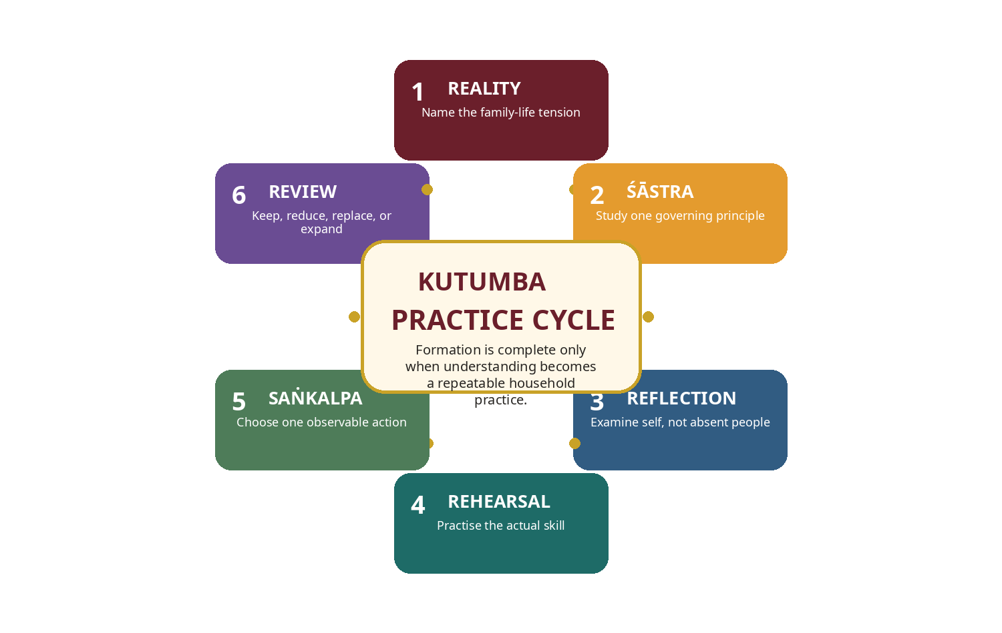
Figure 2. KUTUMBA Practice Cycle

5.1 The six-stage Practice Cycle
Stage | Required function
1. Reality | Begin with a recognizable household tension. Adults must see why the principle matters before abstract explanation.
2. Śāstra | Study one primary passage or incident with enough context to prevent misuse. Avoid quotation piles.
3. Reflection | Examine one’s own conduct, assumptions, habits, and controllable choices—not the defects of absent people.
4. Rehearsal | Practise the sentence, routine, decision, or correction method in the room.
5. Saṅkalpa | Choose one observable action with days, time, duration, participants, likely obstacle, and fallback version.
6. Review | At the next meeting mark complete, partial, or not completed; identify the obstacle; keep, reduce, replace, or expand.
The use of active practice rather than lecture-only delivery is consistent with broad learning research showing stronger outcomes from active learning. The KUTUMBA model applies that principle cautiously to adult devotional formation; it does not claim that one education study validates every family intervention.

5.2 Adult-learning design rules
- Relevant before abstract: establish the family-life problem before presenting the principle.
- One governing principle per session: secondary sources support rather than compete.
- Agency with accountability: adults choose disclosure and practice size, but covenant and safety rules remain binding.
- Skill before aspiration: practise what to say or do, not only what to value.
- Minimum viable practice: create a version that survives pressure.
- Retrieval and review: begin the next session by recalling and evaluating the prior commitment.
- Varied participation: speaking, writing, pair practice, anonymous questions, demonstration, and observation all count.
- No amateur psychology: facilitators describe behavior and choices, not diagnoses or hidden motives.
- No gender stereotyping: cases should not assume that one spouse always leads, earns, cooks, disciplines, or resists.
- No false equivalence: ordinary conflict can be discussed; coercion, violence, abuse, or threat moves to safety pathways.

5.3 Session evidence package
Every parent lesson should contain the following controlled artifacts:
☐ lesson metadata and version; | ☐ central family-life tension;
☐ primary Śrīla Prabhupāda source and context note; | ☐ one-sentence governing principle;
☐ Prem-kī-Kathā script; | ☐ guided-discussion questions;
☐ anonymized case card; | ☐ rehearsal activity;
☐ minimum and stronger application; | ☐ weekly saṅkalpa options;
☐ facilitator boundary and referral notes; | ☐ newcomer adaptation;
☐ materials and timing; | ☐ private assessment prompt;
☐ post-session defect notes.

6. The 20-minute Prem-kī-Kathā method
Prem-kī-Kathā is the bridge between shared worship and parallel formation. It creates recognition and desire to apply; it is not the complete adult lesson and must not absorb the discussion period.
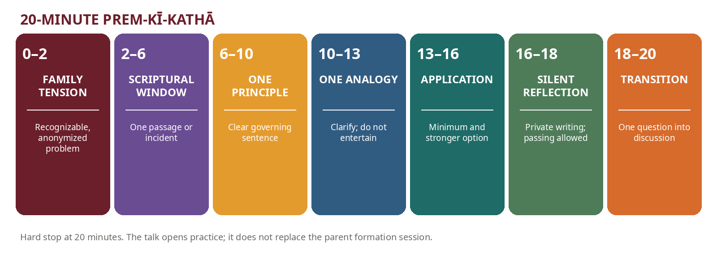
Figure 3. Prem-kī-Kathā timing and purpose

6.1 Required script architecture
Time | Element | Delivery requirement
0–2 minutes | Family tension | State a recognizable, anonymized situation. Do not target a participating family.
2–6 minutes | Scriptural window | Present one verse, passage, or incident with the minimum context needed for accurate use.
6–10 minutes | Governing principle | State one sentence that can guide action. Clarify what the principle does not mean.
10–13 minutes | Analogy | Use one familiar comparison that clarifies the principle; avoid entertainment for its own sake.
13–16 minutes | Household application | Give a minimum application for a struggling family and a stronger option for an established family.
16–18 minutes | Silent reflection | Adults write privately. Passing and non-disclosure are explicitly permitted.
18–20 minutes | Transition | Ask one question that opens the guided parent session; stop on time.

6.2 Example mini-script
FAMILY TENSION
A parent returns home exhausted, sees the children on devices instead of preparing for the family program, and immediately shouts about discipline and Kṛṣṇa consciousness.

Scriptural window: Bhagavad-gītā 3.21 teaches that others follow the example set by a leading person. Bhagavad-gītā 17.15 adds that disciplined speech is truthful, beneficial, pleasing, and nonagitating. The facilitator gives only the context required for the lesson and does not use the verses to claim that parents must never set firm boundaries.
GOVERNING PRINCIPLE
A parent cannot sustainably teach regulation while acting without regulation.

Analogy: a thermostat changes the environment; a thermometer only reacts to it. A parent who merely reflects the household’s agitation cannot guide the emotional climate.
Minimum application: pause for ninety seconds, lower the voice, and state one clear preparation request. Stronger application: agree on a device parking place and a ten-minute transition routine before the program.
Silent reflection: “What lesson did my conduct teach this week, regardless of what my words taught?” Transition question: “Which part of the situation was under the parent’s direct control?”

6.3 Speaker controls
- Use no more than four simple slides.
- Do not exceed one central story, one principle, and one analogy.
- Do not identify or indirectly describe a current family.
- Do not disclose mentor conversations or safeguarding matters.
- Do not generalize negatively about spouses, generations, cultures, professions, or children.
- Do not use guilt regarding guru, initiation, children, service, or community status.
- Do not introduce an unreviewed worship practice, speculative teaching, or internet quotation.
- End at twenty minutes even when the content is unfinished; revise the script afterward.

7. The 40-minute guided parent discussion
The discussion is structured to prevent domination, spouse criticism, and unproductive storytelling. It uses observation, case analysis, application, rehearsal, and commitment.
Minutes | Phase | Facilitator function
0–5 | Observe the text | What happened? What words or actions stand out? What is explicitly stated? What is not being claimed?
5–15 | Examine the case | Identify facts, assumptions, competing responsibilities, avoidable mistakes, and safety boundaries.
15–25 | Apply the principle | What can the parent control? What would worsen the situation? What is a firm but nonhumiliating response?
25–33 | Rehearse | Practise a sentence, request, apology, boundary, routine, or repair step.
33–38 | Choose application | Select a realistic saṅkalpa with normal and fallback versions.
38–40 | Close | Summarize one philosophical principle, one relational skill, and one household action.

7.1 Question ladder
Level | Question type
Discovery | What facts do we know? What does the passage actually say?
Meaning | What principle explains the tension? What misuse must be avoided?
Self-examination | Where do I show this pattern? What am I expecting from others that I do not model?
Choice | Which part is under my control? What could I do in the next ten minutes?
Rehearsal | What exact sentence or sequence would I use?
Commitment | When, where, how long, with whom, and what is the fallback?
Review | What helped, what obstructed, and what will change next week?

7.2 Discussion ground rules
- Speak from “I”; do not prosecute an absent spouse or child.
- Passing is permitted without explanation.
- Do not diagnose or assign motives.
- Do not give unsolicited marital, legal, medical, or psychological advice.
- Do not repeat another family’s story outside the authorized care route.
- Challenge ideas without humiliating people.
- Do not compare rounds, children, finances, knowledge, home standards, or service.
- The facilitator may stop a discussion that is unsafe, dominating, speculative, or outside scope.
- Safety matters are reported privately; they are not put to a group vote.
- The goal is practice and repair—not winning an argument or displaying knowledge.

7.3 Facilitator intervention phrases
Situation | Approved facilitator language
Redirect spouse criticism | “Please bring this back to your own controllable response rather than evaluating someone who is not in the room.”
Stop diagnosis | “We can describe the behavior and impact, but we cannot diagnose the person.”
Protect privacy | “That detail is too personal for the group. We can discuss the general principle or speak privately through the care route.”
Allow passing | “Passing is a complete answer. You may use the written reflection instead.”
Stop unsafe advice | “This may require qualified professional or safety support; we should not solve it in the group.”
Limit domination | “I am going to pause here and hear from someone who has not spoken.”
Return to śāstra | “Which part of our assigned source supports that conclusion?”
Close on time | “We have the principle and action. The unresolved details belong in the next revision, not in an extended session.”

8. Case-study method
A good case is realistic, incomplete, and morally complex enough to require judgment. It should not contain an obvious villain or secretly describe a participating family.

8.1 Case construction rules
- Use fictional names and alter identifying details.
- Include competing legitimate responsibilities such as work, sleep, school, caregiving, health, and service.
- Separate observable facts from assumptions.
- Include at least one choice available in the next ten minutes and one longer-term practice.
- Name the educational boundary and any safety trigger.
- Avoid gender stereotypes and cultural caricatures.
- Do not resolve every case with “chant more.” Include planning, communication, rest, referral, or skill practice where appropriate.
- End with self-application rather than judgment of the fictional family.

8.2 Core case bank
Case | Situation | Learning focus
Two-speed couple | One spouse wants a daily home program; the other is willing to attend only occasionally. | Invitation without coercion; separate shared minimum from personal practice.
Friday exhaustion | Both adults finish work late and repeatedly arrive stressed and unprepared. | Regulation, simplification, and realistic transitions.
Do what I say | A parent demands chanting while remaining on the phone. | Parental modeling and shared standards.
Public correction | A child disrupts kīrtana and is loudly criticized before everyone. | Private, proportionate correction and repair.
Screen conflict | Children resist device-free prasāda because adults check messages throughout meals. | Family media agreement and adult example.
Temple-car gossip | The family discusses another devotee’s marriage and children on the drive home. | Speech discipline, confidentiality, and repair.
Takeout evening | The family is too tired to cook and abandons all remembrance or offering practice. | Minimum viable devotional routine and approved food-offering guidance.
Service overload | One parent accepts several services while the other carries household duties. | Consent, capacity, and household responsibility.
Child resistance | A child says KUTUMBA and temple programs are boring. | Curiosity, relationship, age-appropriate choice, and meaningful service.
Teen doubt | A teenager asks difficult questions and the parent labels it rebellion. | Listening, intellectual honesty, and referral to qualified teachers.
Extended family | Relatives feel judged by the family’s new practices. | Respectful boundaries without superiority.
Financial pressure | A family feels guilty because it cannot donate or attend every event. | Material responsibility, voluntary service, and no comparison.
Unequal discipline | One adult is strict; the other reverses consequences in front of the child. | Private co-parent planning and consistent minimum standards.
Angry apology | A parent says “sorry” but adds blame and demands immediate forgiveness. | Complete apology and patient repair.
Private message | A mentor begins receiving late-night messages from one spouse about the marriage. | Mentor boundaries and transfer to appropriate care.
Oversharing circle | A participant gives detailed information about a child’s diagnosis and spouse’s behavior. | Facilitator interruption, privacy, and consent.
New family comparison | A late-joining family feels inferior to experienced families. | Setu pathway, self-comparison, and starter practices.
Festival burnout | The family attends several events, children lose sleep, and Friday becomes conflict-heavy. | Regulation, protected breaks, and one-principal-program rule.

8.3 Standard case-card questions
- What facts do we actually know?
- What assumptions are the adults making?
- Which responsibilities are legitimate?
- What conduct is clearly unhelpful or unsafe?
- What part can each adult control?
- What scriptural principle applies?
- What should not be concluded from that principle?
- What could be said or done in the next ten minutes?
- What longer-term household practice might help?
- Does this require education, confidential care, or external professional support?

9. Safe participation and the rejection of forced sharing
The adult track should create honest reflection without making the group perform vulnerability. Adults are not required to disclose private struggles to prove sincerity, belonging, or advancement.

9.1 Acceptable participation modes
- Speak in the full group.
- Speak in a pair or triad.
- Write privately.
- Submit an anonymous question.
- Observe a role-play.
- Practise a neutral fictional scenario.
- Pass without explanation.
- Speak only about the principle and planned action.

9.2 Warning signs of emotional performance
- Facilitators praise dramatic disclosure more than quiet consistency.
- Participants feel obliged to match another person’s testimony.
- Tears or silence are interpreted publicly.
- Detailed marital or child information is treated as “honesty.”
- Leaders retell disclosures as inspirational examples.
- Adults use self-criticism to seek reassurance rather than choose an action.
- Public commitments are inflated beyond household capacity.
APPROVED RESPONSE
“I prefer not to discuss the details, but I see that I need to change how I respond when I am angry.” This is sufficient participation.

9.3 Trauma-aware facilitation without becoming therapy
KUTUMBA can apply basic safety principles—choice, predictability, clear boundaries, noncoercion, respectful language, and referral—without attempting trauma treatment. Facilitators do not ask participants to relive traumatic experiences, identify diagnoses, or process clinical symptoms in the group.

PART III | PARENT AND FAMILY FORMATION DOMAINS  The household practices and relational skills KUTUMBA will deliberately form

10. Parent-child bonding
Children are more likely to receive devotional instruction from adults with whom they experience attention, affection, fairness, and repair. Bonding is therefore not an optional social extra; it is part of the learning environment. It must not become permissiveness, manipulation, or forced intimacy.

10.1 The 5–20–1 rhythm
Rhythm | Minimum standard
Daily: 5 minutes | Undistracted attention; one genuine question; listen without immediate correction; appreciation or affection; a natural Kṛṣṇa connection when appropriate.
Weekly: 20 minutes | Child chooses an approved shared activity such as story, music, art, cooking, altar care, nature walk, instrument practice, service, or devotional game.
Monthly: 1 memory | Create one shared devotional memory through cow service, temple visit, cooking, festival preparation, japa walk, family presentation, or helping another family.

10.2 Connection rules
- The parent participates rather than supervising from a phone.
- The five-minute connection is not an interrogation about school, chanting, or behavior.
- The child’s choice is bounded by safety, age, budget, and family values.
- Parents do not demand emotional disclosure from children.
- Affection is not withdrawn as a disciplinary tool.
- Photographs and social posts are not the purpose of the activity.
- A child who resists a spiritual activity should be met first with curiosity about difficulty, boredom, misunderstanding, sensory load, peer dynamics, or the need for meaningful choice.

10.3 Bonding conversation prompts
- What was the best and hardest part of your day?
- What did someone do today that felt kind?
- What is one thing you are wondering about Kṛṣṇa or the world?
- Which activity would you like us to do together this week?
- Was there a moment when I did not listen well to you?
- What would make our family program easier to join?

11. Parents model what children learn
Children receive a lived curriculum. They observe what adults do when tired, corrected, inconvenienced, disappointed, or unrecognized. Bhagavad-gītā 3.21 provides a direct anchor: people follow the example established by those they regard as leaders.

11.1 Visible modeling domains
Domain | What the child must be able to observe
Chanting | Children see adults chant rather than only demand children chant.
Reading | Adults read or hear attentively rather than assigning books they never open.
Speech | Adults restrain gossip, contempt, sarcasm, and shouting in ordinary settings.
Apology | Parents name the action, impact, and repair without adding blame.
Media | Adults follow the family’s device boundaries, including during meals and worship.
Prasāda | Adults pray, serve, avoid criticism, and show gratitude.
Service | Adults serve reliably without competition, resentment, or seeking recognition.
Correction | Adults accept feedback from leaders or family members without retaliation.
Temple conduct | Adults avoid politics, faction-building, and criticism around children.
Material responsibility | Adults work, budget, rest, and meet obligations without allowing them to erase spiritual purpose.
WEEKLY MODELING QUESTION
What lesson did my conduct teach this week, regardless of what my words taught?

11.2 Modeling audit
☐ I followed the same device boundary I expected from my child. | ☐ I completed at least one devotional practice where my child could see ordinary consistency.
☐ I corrected without labeling the child’s identity. | ☐ I apologized for one mistake without defending it.
☐ I avoided gossip about devotees, relatives, or another family. | ☐ I fulfilled or renegotiated a family commitment rather than silently abandoning it.
☐ I showed respect to a spouse or co-parent during disagreement. | ☐ I let the child see service that was calm and not competitive.

12. Communication, anger, speech, and gossip
The governing devotional standard is not merely “say what is true.” Bhagavad-gītā 17.15 combines truthfulness with benefit, nonagitation, and disciplined scriptural speech. Nectar of Instruction 1 places speech, mind, and anger among the urges to be controlled. The parent track converts these principles into an interruptible household process.

12.1 The PAUSE response
Step | Action
P — Pause the body | Stop speaking, lower volume, create safe distance, and avoid following someone through the house to continue the conflict.
A — Assess | Is anyone unsafe? Am I correcting the present behavior or unloading accumulated frustration? Must this be handled now?
U — Understand | Hear one explanation without interruption. Understanding is not the same as approving.
S — State the standard | Use one clear behavioral sentence; avoid character labels, historical accusations, and multiple commands.
E — Encourage repair | Ask what must happen now to make the situation safer or more respectful; return to the relationship after consequence.

12.2 Approved language
Situation | Sample wording
Unsafe action | “That action is unsafe. Stop and come with me.”
Disrespectful speech | “We speak respectfully here. Please try the sentence again.”
Need for reset | “You are not being removed from the family. You are taking a reset from this activity.”
Delayed discussion | “I am too agitated to answer well. We will return to this at 7:30.”
Repair | “What happened, who was affected, and what can you do to repair it?”
Parental error | “I shouted. That was wrong and made it harder for you to hear the instruction. I am sorry. I will repeat it calmly.”
Request to spouse | “I would like us to protect fifteen minutes on Sunday for family practice. Which time would interfere least with your schedule?”

12.3 Language that KUTUMBA rejects
- “You are a bad devotee.”
- “Kṛṣṇa will punish you.”
- “Why can’t you be like that child?”
- “You always embarrass us.”
- “Everyone agrees that you are the problem.”
- Labels such as lazy, useless, demonic, stupid, hopeless, ungrateful, or spiritually fallen.
- Public sarcasm, threats of abandonment, or invoking leaders to frighten a child or spouse.

12.4 Gossip decision test
Test | Question
Ownership | Is this information mine to share?
Awareness | Is the person present, aware, or consenting?
Purpose | Is there a legitimate action, protection, or service reason?
Recipient | Am I speaking to someone authorized and able to help?
Integrity | Would I speak the same way if the person entered the room?
Minimum necessary | Am I sharing only the facts required for the action?
IMPORTANT DISTINCTION
Reporting a safety concern through the approved route is not gossip. Repeatedly circulating the concern after it has been reported is gossip and can compromise safety, fairness, and confidentiality.

13. Parenting as a learnable art
KUTUMBA treats parenting as a sequence of observable skills rather than a fixed personality trait. The aim is neither harsh control nor permissiveness. Parents learn to teach, supervise, correct, apply related consequences, and repair the relationship.

13.1 Skill progression
- Observe and describe behavior accurately.
- Connect before demanding when the situation permits.
- State the expectation in concrete terms.
- Demonstrate and rehearse the expected behavior.
- Notice effort and improvement without excessive praise or comparison.
- Correct privately when possible and immediately when safety requires.
- Use a proportionate, related consequence.
- Allow a path back into the activity.
- Repair after conflict and review repeated patterns.
- Seek qualified help when behavior, development, health, or safety exceeds ordinary support.

13.2 Correction standard
Standard | Meaning
Calm enough to understand | The adult does not need to feel calm, but must be regulated enough to communicate safely.
Behavior-specific | Describe the action; do not define the child’s identity.
Private when possible | Public intervention is for immediate safety or disruption; instruction and consequences move private.
Brief | One standard and one next step; do not deliver a sermon during dysregulation.
Proportionate | The consequence fits the conduct, age, understanding, and pattern.
Related | Repair, restore, practise, pause, or lose access connected to the behavior.
Restorative | The child knows how to return to the family or activity.
Documented only when necessary | Program incidents follow the safety procedure; ordinary parenting moments are not turned into records.

13.3 Positive discipline and safeguarding alignment
Current American Academy of Pediatrics parent guidance emphasizes calm teaching, modeling, clear limits, attention to good behavior, and nonphysical strategies. KUTUMBA’s internal standard is stricter for program activities: no physical punishment, no public humiliation, no threatening spiritual consequences, and no adult disciplining a child outside the designated program process.
PARENTS REMAIN RESPONSIBLE
The whole community should love and protect children, but designated trained adults run the formal children’s program. Other adults report concerns to the assigned teacher or safety lead rather than independently correcting someone else’s child.

14. Marriage and household cooperation boundaries
The parent track may teach cooperation skills. It does not govern private marriages, determine fault, or create religious pressure between spouses. One spouse’s enthusiasm does not grant authority to impose every preferred practice on the other.

14.1 Teachable cooperation skills
- Making a specific request rather than a global accusation.
- Listening and summarizing before responding.
- Dividing preparation, childcare, transport, cooking, and service responsibilities.
- Recognizing invisible or unequal household labor.
- Discussing children privately rather than contradicting each other publicly.
- Agreeing on a shared minimum while allowing individual devotional practices.
- Apologizing, repairing, and revising an unrealistic plan.
- Protecting sleep, employment, medical care, and essential family obligations.
- Allowing different rates of spiritual development without mockery or coercion.

14.2 The household cooperation meeting
Step | Household action
1. Appreciate | Name one contribution from the other adult.
2. Review facts | Calendar, work hours, children’s needs, health, service, transport, and food.
3. Name one pressure | Avoid a list of historical grievances.
4. Make one request | Specific, time-bounded, and negotiable.
5. Agree on minimum | Define the smallest shared practice or responsibility.
6. Assign ownership | Who prepares, reminds, transports, cleans, or leads?
7. Set review time | Revisit after one or two weeks rather than arguing daily.

14.3 Prohibited uses of KUTUMBA
- Publicly correcting or embarrassing a spouse.
- Quoting a spouse’s private disclosure.
- Asking the group or mentor to decide who is right.
- Using the mentor to pressure the reluctant spouse.
- Invoking guru, initiation, children, or community standing to compel compliance.
- Creating a secret alliance between a mentor and one spouse.
- Presenting one cultural division of roles as mandatory for every family.
- Encouraging a person to remain in danger in the name of tolerance or family unity.
REFERRAL BOUNDARY
Persistent destructive conflict, coercive control, violence, threats, serious addiction, infidelity crises, custody disputes, or separation decisions require appropriately qualified assistance. They are not group case studies.

15. Devotional routines for working families
The routine must survive real life. A plan that depends on ideal mornings, abundant free time, equal enthusiasm, and perfect children is not a plan. Bhagavad-gītā 6.17 supports regulation in eating, recreation, work, sleep, and wakefulness rather than unmanaged extremes.

15.1 Three operating levels
Level | Frequency | Core pattern | Typical duration
Level 1 — Starter | Three days each week | 2 minutes settling/prayer + 5 minutes chanting + one verse, paragraph, or short story + one sentence of reflection | Approximately 10 minutes
Level 2 — Steady | Five days each week | 10 minutes chanting + 5–10 minutes reading/hearing + brief family prayer + regular offering of a designated meal | Approximately 15–25 minutes
Level 3 — Established | Most days | Individual adult sādhana according to capacity + protected family chanting/reading + consistent offerings + weekly service + temple/festival participation | Family-specific

15.2 Routine-design rules
- Attach the practice to an existing event such as breakfast, dinner, school return, or bedtime.
- Use the same location and prepare books, beads, instruments, or offering items beforehand.
- Start shorter than the family believes it can manage.
- Stop before children are chronically exhausted or resentful.
- Define a normal version and a fallback version.
- Do not turn one missed day into a moral crisis.
- Review the routine after six weeks and after major schedule changes.
- Separate the family minimum from each adult’s personal practice.
- Do not add multiple new practices in the same week.
- Protect planned rest weeks and family emergencies.

15.3 Implementation-intention format
Research on implementation intentions supports converting a goal into an “if–then” plan that specifies the situation and response. KUTUMBA uses a simplified form:
PLAN FORMULA
After [existing event] on [days], at [place], we will [practice] for [duration]. If the normal version is not possible, we will use [fallback version].

Example: “After dinner on Monday, Wednesday, and Saturday, we will chant together in the living room for eight minutes. If we return home late, we will chant for three minutes before bedtime.”

16. Home chanting and reading

16.1 Chanting progression
Stage | Practice
Entry | One fixed family kīrtana or chanting period each week.
Emerging | Three short periods each week.
Steady | Five or more regular periods; individual adults deepen separately.
Established | A stable daily family anchor where feasible, without using it to police one another.
Integrated | Children take age-appropriate participation through response singing, approved instruments, setup, or leading a repeated line.

16.2 Reading method: one passage, one question, one action
Step | Prompt
Read | A short, assigned passage from an approved source.
Recall | What happened or what did Kṛṣṇa teach?
Understand | What does it show us?
Apply | What could we do differently today?
Record | One sentence or drawing if useful; do not turn family reading into a test.

16.3 Working-family adaptations
- Use approved audio during commuting or household work, but retain some focused reading or discussion.
- Allow younger children movement, drawing, props, or a short participation window.
- Do not force children to sit silently beyond developmental capacity.
- Use the same short passage across adult and child tracks so family discussion is possible.
- When one spouse does not participate, the participating adult avoids ridicule and protects a small, peaceful practice.
- For travel or illness, use the fallback routine and resume without a punitive “catch-up.”

17. Offering food in the home
Bhagavad-gītā 9.27 provides the integrating principle that food and ordinary activity can be offered to Kṛṣṇa. The parent track teaches a simple household workflow. Exact mantras, altar standards, and worship procedures remain under the approved KUTUMBA worship system and qualified ISKCON guidance.

17.1 Progressive pathway
Stage | Household practice
Stage 1 | Offer one designated home-prepared meal several times each week.
Stage 2 | Offer one principal meal each day.
Stage 3 | Offer all suitable home-prepared meals consistently.
Stage 4 | Strengthen cleanliness, planning, ingredient awareness, gratitude, and children’s age-appropriate participation.

17.2 Simple workflow
- Plan a simple suitable meal and approved ingredients.
- Maintain personal and kitchen cleanliness.
- Avoid tasting before offering.
- Place a portion on the designated offering plate.
- Follow the approved offering procedure.
- Wait for the agreed period and keep offered/unoffered food practices clear.
- Return and distribute the prasāda respectfully.
- Involve children through safe, age-appropriate preparation, plate setup, prayer, serving, or cleanup.

17.3 Boundaries and busy-evening design
- Simplify the menu rather than abandon the practice.
- Maintain a small list of quick no-onion/no-garlic meals that meet household standards.
- Do not independently invent rules for restaurant food, packaged items, fasting, or Deity worship.
- Do not criticize another family’s food or compare offerings.
- Allergy, medical, and dietary needs remain legitimate and must be handled safely.
- The offering process is devotional worship, not a child performance or household competition.

18. Screen and media culture
The objective is not technological purity. It is to protect attention, relationships, sleep, learning, privacy, and devotional remembrance. Current AAP guidance has shifted beyond simple time limits toward quality, context, conversation, healthy modeling, and a family media plan.

18.1 Family media agreement
☐ Device-free worship periods. | ☐ Device-free prasāda or family meals, with defined urgent-work exceptions.
☐ A shared overnight charging location appropriate to age and safety. | ☐ Age-appropriate content and privacy settings.
☐ Rules for social media, gaming, group chats, advertisements, influencers, and purchases. | ☐ Expectations for parents as well as children.
☐ What happens when the agreement is broken. | ☐ How school, work, disability, communication, or travel needs are handled.
☐ When the agreement will be reviewed. | ☐ What may and may not be photographed or posted about children and other families.

18.2 The 5C review for any media practice
C | KUTUMBA family question
Child | Age, temperament, developmental needs, vulnerabilities, and current behavior.
Content | Quality, values, ads, violence, sexual content, misinformation, and commercial pressure.
Calm | Is the device the automatic response to every boredom, distress, or transition?
Crowding out | What is displaced—sleep, movement, reading, family talk, worship, outdoor time, or service?
Communication | Do adults discuss what children see and model the same rules?

18.3 Media operating principles
- Content quality matters as much as duration.
- Devices are not the automatic response to boredom or emotional distress.
- Restrictions are explained before enforcement.
- Teen privacy is respected within legitimate safety boundaries.
- Monitoring practices should normally be disclosed; immediate safety concerns follow the safety procedure.
- Parents do not post humiliating stories, photographs, diagnoses, or disciplinary incidents involving children.
- Adults do not check messages throughout kīrtana and then define only the child’s device use as spiritually harmful.
- The media plan is reviewed after major age, school, technology, or family changes.

19. Material responsibility and spiritual growth
KUTUMBA rejects two weak extremes: using work and family duties as a permanent excuse for no spiritual practice, and neglecting livelihood, health, sleep, marriage, children, or essential bills in the name of spiritual enthusiasm. A responsible householder integrates duty and devotion through regulation, offering, simplicity, and service.

19.1 Capacity guardrails
- No KUTUMBA commitment should require neglecting essential employment or legal obligations.
- Unsafe sleep deprivation is not treated as spiritual advancement.
- Children may not be left unsupervised so adults can attend or serve.
- Essential bills, necessary medical care, and food security take priority over optional donations or travel.
- One spouse may not pressure the other to donate, host, or accept service.
- Families do not attend multiple KUTUMBA events every week; festivals and outings replace the regular program when scheduled.
- Service is reduced when the household is in crisis, illness, bereavement, job transition, or caregiving overload.
- Growth should create greater clarity, simplicity, responsibility, and service—not unmanaged burnout.

19.2 Capacity check before accepting service
Check | Question
Time | Do we have the actual preparation and recovery time?
Consent | Have affected adults agreed, not merely remained silent?
Children | Who will supervise and how will sleep/school be protected?
Health | Is the task safe given current physical and mental capacity?
Money | Does it create avoidable cost or financial pressure?
Skill | Have we been trained and can we ask for help?
Backup | What happens if work, illness, or weather changes the plan?
Recovery | Will we need to reduce another commitment that week?
PART IV | FAMILY CARE, MENTORING AND ACCOUNTABILITY  Support without control; care without amateur treatment

20. Confidential care versus public discussion
Loving devotional exchange can include confidential inquiry and revealing one’s mind, but that does not place every private matter in a group circle. KUTUMBA uses a three-zone model that protects both honest discussion and safety.
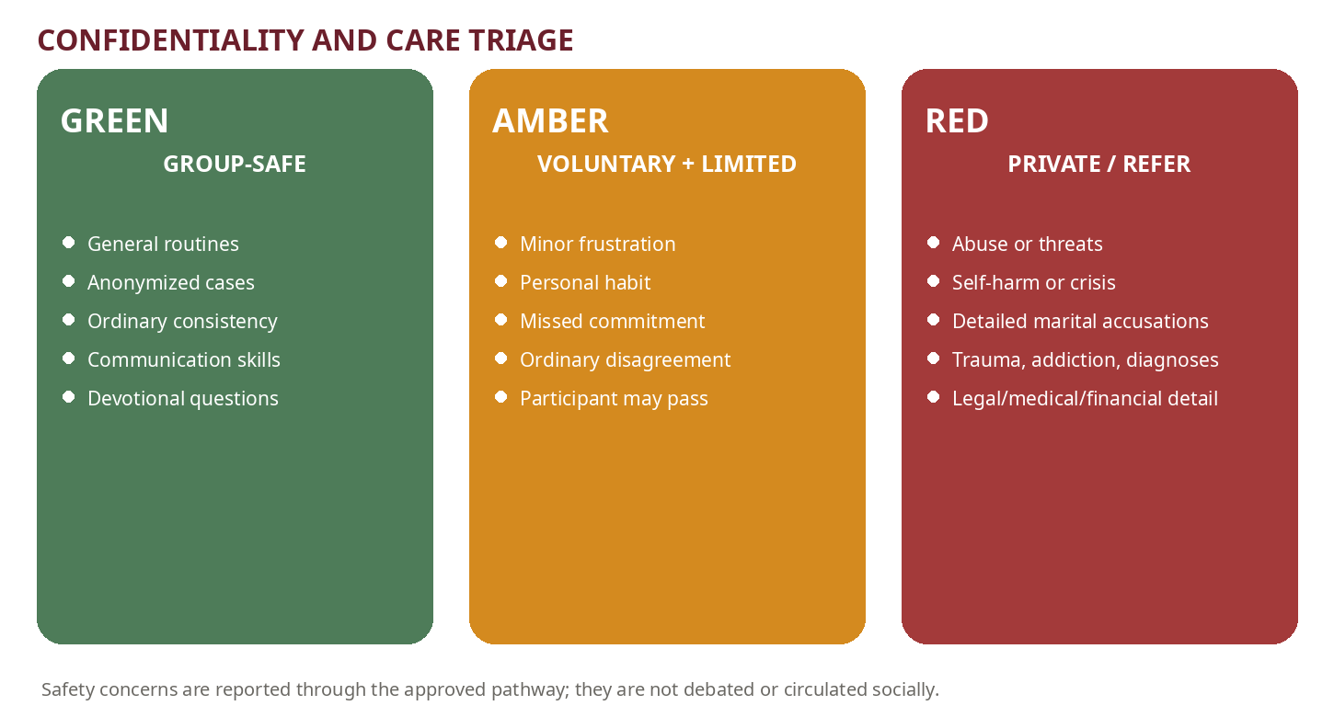
Figure 4. Confidentiality and care triage

20.1 Green, amber, and red zones
Zone | Examples | Response
Green — group-safe | General routines; anonymized cases; ordinary struggles with consistency; communication skills; parenting questions; devotional doubts stated without identifying third parties. | Facilitated group discussion.
Amber — voluntary and limited | Personal habit; frustration; minor disagreement; missed commitment; ordinary motivation difficulty. The participant controls detail and may pass. | Brief sharing, private writing, or mentor check-in.
Red — private/refer | Detailed marital accusations; abuse; threats; self-harm; trauma; addiction; child diagnosis; legal, medical, immigration, custody, or detailed financial information. | Stop group detail; activate care/safety/referral route.

20.2 Confidentiality promise
KUTUMBA should use precise language rather than promising absolute secrecy:
“We will limit personal information to people who need it for care, safety, or required action. We cannot promise secrecy when a child or adult may be unsafe, when reporting is legally required, or when urgent professional help is needed.”
Recommended orientation wording

20.3 Information-handling rules
- Do not record group disclosures.
- Do not store private mentor notes, child information, medical details, or family contact data in Git.
- Do not post sensitive information in broad group chats, email chains, shared drives, or presentation tools.
- Do not forward screenshots of private conversations.
- Record only operationally necessary facts, dates, actions, and recipients.
- Restrict access based on role and review access periodically.
- Do not use a disclosure in lesson examples, even with names removed, unless explicit informed permission and safety review exist.
- Do not promise secrecy where safety or reporting duties apply.
- Delete temporary notes according to the approved retention schedule.
- Report a confidentiality breach promptly to the Program Director and Safety/Care Lead.

20.4 Minimum incident record
Field | Record requirement
Date/time | When the concern was observed or disclosed.
Reporter/receiver | Names and roles of people directly involved in receiving the concern.
Observable facts | Exact words or behavior when material; no diagnosis, speculation, or character judgment.
Immediate safety action | What was done to protect the child/adult or secure emergency help.
External/internal contact | Who was contacted, when, by what approved route, and any confirmation number.
Information shared | Only what was necessary and with whom.
Next required step | Named owner and due date; no informal investigation.
Storage location | Restricted approved record system, never the public curriculum repository.

21. Mentor-family system
Mentor families help participants understand the program, establish routines, complete Setu, choose realistic saṅkalpas, and connect to the right leader. They are not miniature gurus, professional counselors, investigators, sponsors, or substitute family authorities.

21.1 Mentor selection criteria
☐ Stable participation and reasonable personal practice over time. | ☐ Discretion and a demonstrated refusal to gossip.
☐ Respectful family conduct, including willingness to apologize and accept correction. | ☐ Reliability in communication and service.
☐ Ability to listen without quickly advising or controlling. | ☐ Acceptance of the KUTUMBA source hierarchy, safeguarding rules, and referral boundaries.
☐ Completion of mentor orientation, confidentiality, child-protection, and escalation training. | ☐ No active conflict of interest with the assigned family.
☐ Willingness to be supervised, corrected, reassigned, or removed from the role.
CAPACITY LIMIT
During the founding phase, one mentor family should support no more than two participating families. If qualified mentors are not available, use structured leader check-ins rather than appointing weak mentors.

21.2 Mentor responsibilities
- Welcome the family and explain the weekly flow.
- Help complete KUTUMBA Setu and identify a realistic starter practice.
- Check whether instructions, schedules, service roles, and child placement are understood.
- Ask about the family’s chosen practice without policing private details.
- Help reduce or redesign commitments after failure.
- Encourage respectful temple participation and connection to approved resources.
- Notice disengagement, overload, boundary concerns, or unresolved safety issues and escalate appropriately.
- Complete a brief cycle review using only necessary information.

21.3 Mentor prohibitions
- Counseling a couple as if professionally qualified.
- Meeting secretly with one spouse to discuss the other.
- Becoming the primary authority over a child.
- Private adult-child messaging or closed-door meetings.
- Lending or borrowing substantial money, soliciting business, or requesting donations.
- Diagnosing conditions or interpreting trauma.
- Promising absolute confidentiality.
- Changing philosophical, worship, attendance, or safety standards.
- Keeping an independent case file outside the approved system.
- Using the role to recruit followers, gain status, or control service assignments.

21.4 Contact rhythm
Point | Expected contact
Entry | Welcome contact within several days; explain Setu, first visit, children’s transition, and practical questions.
Most active weeks | Brief check-in focused on participation and the chosen practice; not a compulsory counseling call.
Monthly | Twenty-to-thirty-minute conversation if useful.
Cycle end | Structured review of practice, barriers, belonging, service capacity, and next-cycle priority.
As needed | Transfer sensitive matters to the designated lead; urgent safety follows the escalation plan immediately.

21.5 Mentor conversation structure
Step | Mentor prompt
Connect | How is the family doing generally? What has been helpful?
Clarify | What practice did you choose, and what version did you actually attempt?
Recognize | What worked, even partially?
Diagnose the plan—not the person | Was the obstacle time, clarity, energy, environment, disagreement, skill, or overload?
Redesign | Keep, reduce, replace, or expand. Define the fallback version.
Check boundaries | Is there anything that belongs with the facilitator, care lead, safety lead, or qualified professional?
Close | Confirm one next action and the next check-in. Do not create dependency.

22. Home-practice accountability
Accountability must be specific enough to produce action and private enough to avoid comparison or false reporting. The unit of accountability is the family’s own chosen practice against its own prior baseline.

22.1 Saṅkalpa specification
Field | Required answer
Practice | What exactly will we do?
Trigger | After or before which existing event?
Days | Which days this week?
Time/place | Approximately when and where?
Duration | How long?
Participants | Who is invited or responsible?
Likely obstacle | What will probably interfere?
Fallback | What smaller version still preserves the habit?
Review | Complete / partly complete / not complete; why?
Decision | Keep / reduce / replace / expand.

22.2 Valid and invalid commitments
Status | Commitment | Reason
Invalid | “Become more spiritual.” | Not observable or scheduled.
Invalid | “Chant every day no matter what.” | No duration, trigger, fallback, or capacity check.
Invalid | “Make my spouse attend.” | Attempts to control another adult.
Valid | “After dinner Monday, Wednesday, and Saturday, we will chant for eight minutes; fallback is three minutes before bed.” | Specific and resilient.
Valid | “I will put my phone in the charging area during Friday kīrtana and prasāda.” | Models the desired media boundary.
Valid | “Before correcting our child this week, I will use one PAUSE step and state one behavior-specific standard.” | Skill-based and observable.

22.3 Review response
Result | Facilitator/mentor response
Completed | Recognize consistency; do not automatically increase. Ask whether it was sustainable and meaningful.
Partly completed | Identify what portion worked; preserve the successful component and redesign the weak point.
Not completed | Do not shame. Determine whether the plan lacked clarity, capacity, agreement, cue, skill, or value.
Repeated noncompletion | Reduce to a minimum viable practice; consider resistance, overload, or a different domain.
Hidden reporting | If a family reports what it thinks leaders expect, restore privacy and remove public comparison.
Conflict over practice | Separate shared minimum from personal practice; move serious marital issues outside the accountability process.

22.4 Prohibited accountability methods
- Public round-count reporting or ranking.
- Family leaderboards, streak boards, or badges tied to spiritual worth.
- Comparing children’s memorization, behavior, or participation.
- Asking spouses to report on each other.
- Publishing attendance or practice failures.
- Using access to service or belonging as punishment for an ordinary failed practice.
- Treating visible enthusiasm as evidence of readiness for leadership.

23. Resistant-parent engagement
Resistance is data, not automatically disobedience. It may arise from exhaustion, prior religious harm, fear of control, philosophical doubt, social discomfort, child concerns, unequal labor, overscheduling, language barriers, or feeling judged by experienced devotees.

23.1 Engagement pathway
Step | Action
1. Listen | Ask privately: “What part of the program feels least useful or most difficult?”
2. Identify the actual barrier | Do not answer a time problem with more philosophy or a trust problem with more pressure.
3. Offer a low-risk entry point | Kīrtana and prasāda; one family activity; one service; one short recording; one ten-minute practice; one cycle trial.
4. Run a four-week experiment | Choose a practice linked to the parent’s stated concern.
5. Review honestly | Ask whether anything improved; do not manufacture success.
6. Respect adult choice | One spouse may participate more; do not publicly pursue the reluctant spouse.
7. Enforce covenant boundaries | Skepticism is allowed; repeated disruption, ridicule, safety violations, or undermining children’s protection is not.

23.2 Engagement options by barrier
Barrier | Practical response
Time/exhaustion | Starter routine; fallback version; arrive for only the core program during a temporary overload; reduce service.
Fear of judgment | Private baseline; no public reporting; mentor who understands the boundary.
Lecture boredom | Case role, discussion, practical lab, or facilitator feedback role.
Philosophical doubt | Written question; approved source; qualified teacher; no forced agreement.
Spouse mismatch | Shared minimum plus individual practice; no public pressure.
Child resistance | Child-choice activity; age-appropriate role; teacher consultation; shorter participation.
Prior harmful religious experience | Predictability, choice, explicit limits on authority, and referral when needed.
Social discomfort | Observer status, smaller group, defined service, or Setu before full participation.
Language/access | Simplified language, glossary, translated summary, audio, or visual materials where feasible.

23.3 When engagement becomes an admission decision
A parent does not need to display enthusiasm. However, participation may need to pause or end when an adult repeatedly violates safety rules, humiliates children or families, circulates confidential information, disrupts instruction, pressures others spiritually, refuses all operating expectations, or creates an environment the small cohort cannot safely manage. Removal follows the approved governance process, not an informal mentor decision.

PART V | PROGRESSION, ASSESSMENT AND CURRICULUM INTEGRATION  Private growth, clear standards, no competition

24. Gradual commitment pathway
Commitment develops through observed stability and voluntary responsibility. The pathway is developmental, not a rank system. Families may pause, repeat a stage, or progress differently across domains.
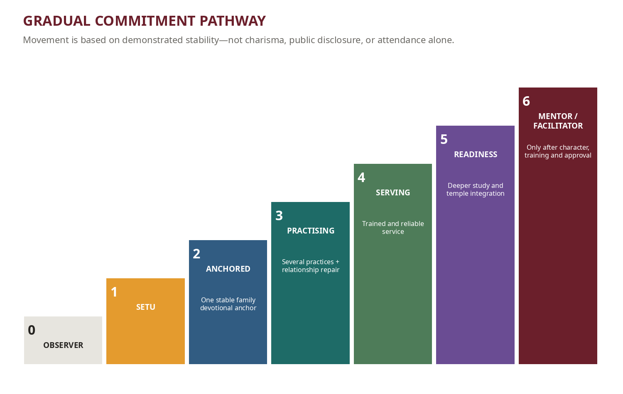
Figure 5. Gradual commitment pathway

24.1 Stage definitions
Stage | Definition
0 — Observer | Attends up to two sessions; learns the flow; no service or practice commitment.
1 — Setu family | Completes orientation, covenant, foundational philosophy/culture modules, forms, and one starter practice; receives mentor support.
2 — Anchored family | Maintains one regular chanting or reading anchor, begins offering food, follows safety/communication standards, and attends with reasonable consistency.
3 — Practising family | Maintains several home practices, demonstrates improving speech and repair, and participates in appropriate service.
4 — Responsible serving family | Completes service training, fulfils roles reliably, communicates early, and does not neglect household responsibilities.
5 — Readiness and deeper study | Demonstrates stable practice, growing comprehension of Śrīla Prabhupāda’s books, temple integration, and understanding of formal study/initiation seriousness.
6 — Mentor/facilitator consideration | Requires character, discretion, philosophical reliability, training, supervision, safeguarding compliance, and explicit leadership approval.

24.2 Movement criteria
- Practice is reasonably consistent for the family’s actual circumstances.
- The family can recover after disruption instead of abandoning the system.
- Adults respect confidentiality, safety, and anti-gossip standards.
- Service commitments are reliable and appropriately sized.
- Parents increasingly model what they ask of children.
- The family accepts correction without retaliation or faction-building.
- No unresolved safety or serious boundary concern blocks increased responsibility.
- The family understands that stage movement is not initiation or spiritual status.

25. Assessment and progress review
Assessment is descriptive, private, and multidimensional. No single score defines a family. The aim is to choose the next helpful practice and identify risks, not to create spiritual competition.
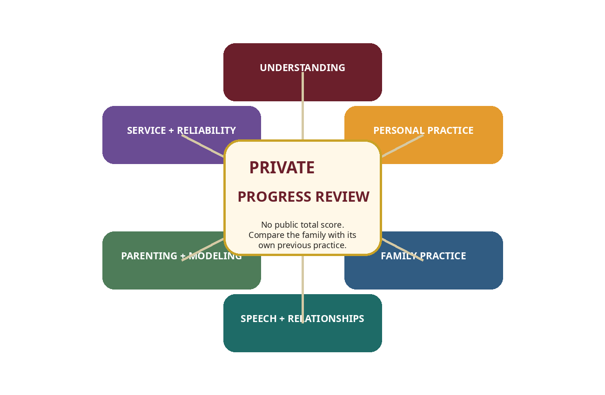
Figure 6. Six private assessment domains

25.1 Six domains
Domain | Review question
Understanding | Can the parent explain the central principle accurately, in context, and without speculation?
Personal practice | Is there a meaningful personal devotional anchor appropriate to current capacity?
Family practice | Does the family chant, read, offer food, worship, serve, or remember Kṛṣṇa together with reasonable regularity?
Speech and relationships | Is the adult improving in anger regulation, truthful/beneficial speech, confidentiality, apology, and repair?
Parenting and modeling | Does the parent demonstrate the conduct expected from children and correct without humiliation?
Service and reliability | Does the adult fulfil or renegotiate commitments without overloading the household?

25.2 Four-level rubric
Level | Description
0 — Not examined | The area has not been considered, taught, or attempted.
1 — Experimenting | The family has begun but is inconsistent, unclear, or dependent on reminders.
2 — Developing | The practice is regular enough to affect household life but breaks under pressure.
3 — Stable and self-correcting | The practice is reasonably established and the family can recover, redesign, and continue after disruption.
NO COMPOSITE SCORE
Do not total the six domains, publish results, rank families, or use the rubric as a substitute for pastoral judgment, safeguarding review, temple requirements, or authorized initiation processes.

25.3 Review cadence
Cadence | Review
Weekly | One-minute private saṅkalpa review.
End of each six-week active cycle | Short reflection and mentor/facilitator conversation.
Six months | Structured family review: strongest change, least stable area, household barrier, relationship impact, child response, service capacity, next priority.
Annually | Private development conversation and revised family practice plan.
Before role expansion | Separate suitability review for service, mentoring, facilitation, worship, or children’s responsibilities.

25.4 Program-level indicators
Program evaluation should aggregate only what is necessary and avoid sensitive family detail. Useful indicators include:
- percentage of active families selecting a realistic saṅkalpa;
- percentage reporting complete, partial, or redesigned—not individual names;
- facilitator adherence to the 20-minute and 40-minute structures;
- number of lessons requiring philosophical or safeguarding correction;
- mentor check-ins completed within role;
- retention at cycle boundaries rather than week-to-week pressure;
- participation spread—whether a few adults dominate;
- service reliability and early cancellation communication;
- confidentiality or boundary incidents and corrective action;
- parent-reported usefulness, pressure, belonging, and clarity;
- child-track observations concerning parental modeling and family follow-through, without public comparison.

25.5 Measures the program must not use
- Public round counts or devotional practice leaderboards.
- Children’s memorization or behavior rankings.
- Amount donated, cost of prasāda, size of home, or number of temple visits as spiritual worth.
- Emotional disclosure as evidence of sincerity.
- Attendance alone as readiness for service or leadership.
- Private marital information as a progress metric.
- Initiation recommendation as a promised graduation outcome.

26. Parent formation across three years
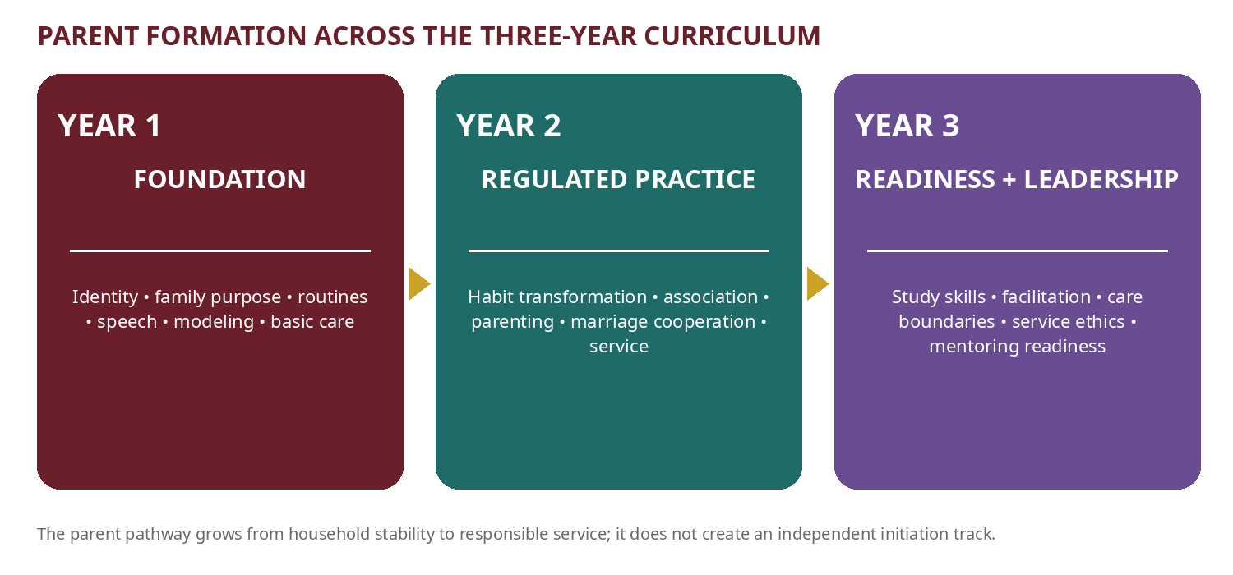
Figure 7. Parent formation across the three-year KUTUMBA curriculum

26.1 Year 1 — Sambandha and family foundations
- Family identity and purpose; parents do not outsource spiritual education.
- Body and soul applied to dignity, labeling, achievement, and correction.
- Human life, priorities, calendar, and material expectations.
- Karma, responsibility, and related consequences.
- Three modes applied to food, media, sleep, clutter, sound, and association.
- Kṛṣṇa, guru, sādhu, śāstra, the holy name, and nine processes of bhakti.
- Starter chanting, reading, offering, altar, festival, and service rhythms.
- Basic speech discipline, anti-gossip, correction, and parental modeling.
- Setu onboarding and one stable family devotional anchor.

26.2 Year 2 — Abhidheya and regulated practice
- Habit transformation, mind and senses, and more stable japa/readings.
- Association, boundaries, Vaiṣṇava-aparādha prevention, reconciliation, and repair.
- Devotional marriage and household cooperation without coercion.
- Raising children with clearer routines, media standards, age-appropriate service, and nonhumiliating correction.
- Time management, work pressure, health, and sustainable service.
- Family meetings, role division, festival preparation, home-program participation, and temple service.
- Mentor-supported self-correction and a family project or outreach service.

26.3 Year 3 — Śāstric readiness, service, and leadership
- How to study Śrīla Prabhupāda’s books and distinguish evidence, context, and application.
- Facilitation, servant leadership, source discipline, and teaching without speculation.
- Devotee-care limits, confidentiality, child protection, referral, and service ethics.
- Leading a simple home discussion or approved practical activity.
- Supporting newcomers without creating dependence or authority inflation.
- Personal spiritual development plan and readiness for formal study.
- Separate qualification review for mentors, facilitators, and leaders.

27. First six-month parent formation overlay
The first six months cover three seven-week cycles. Five active instructional/application weeks are followed by one integration week and one protected off week. The following overlay aligns the adult track with the central curriculum themes.

27.1 Cycle 1 — Identity and the Human Problem
Week/theme | Parent focus | Home application
1. Why are we here? | Spiritual education cannot be outsourced to a weekly teacher. | Hold a ten-minute family purpose meeting.
2. I am not this body | Correct behavior without defining a child by body, achievement, diagnosis, or mistake. | Remove one recurring negative label from household speech.
3. The nature of the soul | Dignity, patience, and loving the person without approving every action. | Five minutes of undistracted connection with each child.
4. Human life is rare | The family calendar teaches children what adults truly value. | Reduce one low-value weekly activity or protect one devotional anchor.
5. Temporary world | Unrealistic expectations placed on marriage, children, career, possessions, or entertainment. | One gratitude and expectation-reset conversation.
6. Integration | Build a practical family identity statement and starter rhythm. | Complete Family Purpose Statement + Starter Routine.
7. Off week | Protected rest; no makeup class. | Use the fallback practice only.

27.2 Cycle 2 — Karma, Rebirth, and Material Nature
Week/theme | Parent focus | Home application
1. Action and reaction | Related consequences instead of arbitrary punishment. | Replace one repeated threat with a clear related consequence.
2. Free will and responsibility | Stop blaming others for one’s uncontrolled response. | Use PAUSE during one conflict and record the repair.
3. Birth, death, and reincarnation | Answer children honestly and age-appropriately without fear tactics. | Prepare one age-appropriate explanation or question box.
4. Three modes | Food, sound, media, sleep, clutter, and speech shape the home. | Change one environmental influence.
5. Māyā and attachment | Screens, comparison, consumption, and overscheduling. | Implement one shared device boundary.
6. Case-study night | Apply principles across a complex family situation. | Complete communication, media, and correction agreements.
7. Off week | No regular gathering. | Review whether agreements were realistic.

27.3 Cycle 3 — Kṛṣṇa, Guru, and the Process of Bhakti
Week/theme | Parent focus | Home application
1. Who is God? | Is Kṛṣṇa present in decisions or only in religious language? | Connect one ordinary duty to service to Kṛṣṇa.
2. Who is Kṛṣṇa? | Build an affectionate family relationship with Kṛṣṇa. | Let children choose one approved story, song, or offering activity.
3. Guru, sādhu, śāstra | Proper authority without personality worship, control, or selective quotation. | Verify one household practice from an approved source.
4. Śrī Caitanya and the holy name | Make chanting accessible and regular rather than punitive. | Three short family chanting periods.
5. Nine processes of bhakti | Families may have different strengths while retaining core practices. | Choose one additional process of bhakti for the week.
6. Integration presentation | Convert learning into a six-month family plan. | Plan chanting, reading, offering, service, media, relationships, and temple participation.
7. Off week | Protected pause. | No additional KUTUMBA assignment.

27.4 Integration-week outputs
☐ One-page family purpose statement. | ☐ Current routine and fallback routine.
☐ Communication and repair agreement. | ☐ Family media agreement.
☐ Food-offering progression choice. | ☐ Parent-child bonding rhythm.
☐ Service capacity and boundary statement. | ☐ One next-cycle learning priority.
☐ Private note of any care/referral need.
PART VI | IMPLEMENTATION, GOVERNANCE AND QUALITY CONTROL  Build the operating capability before asking families to depend on it

28. Staffing model
For ten to twelve adults, the parent track requires at least one trained lead facilitator, one co-facilitator, and a designated care/safety contact outside the ordinary discussion role. One person may initially hold multiple administrative roles, but safety authority and confidential escalation should not depend entirely on the lead speaker.

28.1 Minimum roles
Role | Minimum responsibility
Parent-Track Lead | Owns curriculum delivery, facilitator calibration, cycle review, and parent-track changes.
Lead Facilitator | Prepares and delivers the assigned lesson; protects source, timing, and discussion boundaries.
Co-facilitator | Tracks time, participation spread, boundary risks, anonymous questions, and improvement notes; takes over when the lead has a conflict.
Care/Safety Contact | Receives sensitive concerns, owns the current referral directory, and coordinates approved escalation.
Curriculum/Philosophy Reviewer | Checks source accuracy, application, and absence of speculation before release.
Mentor Coordinator | Selects, trains, assigns, supervises, and reassigns mentor families.
Documentation Owner | Versions lesson packs, publishes approved material, and keeps private information out of the repository.

28.2 Group-size controls
Condition | Operating response
Up to 12 adults | One facilitator + one co-facilitator; full-group discussion with pairs/triads.
13–14 adults | Use structured turns and split rehearsal groups; monitor domination and privacy.
More than 14 regular adults | Normally split into two parent discussion groups with trained facilitators.
More than 2 families per mentor | Add qualified mentors or replace weekly mentor contact with centralized structured check-ins.
Insufficient safeguarding capacity | Do not expand enrollment; resolve staffing and training first.

29. Facilitator and mentor training

29.1 Parent facilitator training sequence
Module | Coverage
Module 1 — KUTUMBA identity | Charter, source hierarchy, three-year architecture, Friday flow, and non-negotiables.
Module 2 — Adult-learning method | Practice Cycle, active participation, rehearsal, saṅkalpa design, and review.
Module 3 — Prem-kī-Kathā | Twenty-minute script, timing, analogy, application, and hard-stop practice.
Module 4 — Guided discussion | Question ladder, participation control, spouse criticism, passing, anonymous questions, and closure.
Module 5 — Care boundaries | Green/amber/red triage, confidentiality wording, referral triggers, documentation, and role limits.
Module 6 — Safeguarding | Current ISKCON policy, Pennsylvania reporting/clearance review, child-protection practices, and emergency procedure.
Module 7 — Practice coaching | Fallback plans, resistance, implementation intentions, and noncompetitive assessment.
Module 8 — Observed practicum | Facilitator delivers a full session; reviewer scores timing, source, safety, participation, and application.
Module 9 — Correction and authorization | Defects are corrected; leader authorizes a defined scope and review date.

29.2 Mentor training sequence
Module | Coverage
Role and limits | Support routines and belonging; do not counsel, investigate, diagnose, finance, or control.
Listening | Open questions, reflection, silence, and avoiding premature advice.
Practice redesign | Identify cue, capacity, skill, agreement, and fallback problems.
Confidentiality | Need-to-know sharing, secure communication, no screenshot forwarding, and no private case files.
Safeguarding and referral | Recognize triggers; preserve facts; contact approved lead/authority; no internal investigation.
Marriage boundary | No secret alliance, triangulation, or spiritual pressure between spouses.
Children’s boundary | No private messaging, unsupervised contact, or independent discipline.
Supervision | Monthly mentor calibration, case-free learning review, incident reporting, and reassignment.

29.3 Authorization evidence
☐ Completed required orientation and safeguarding training. | ☐ Accepted written role and confidentiality agreement.
☐ Passed source and boundary knowledge check. | ☐ Demonstrated intervention phrases in role-play.
☐ Delivered or observed a practicum. | ☐ Understands reporting and emergency contacts.
☐ No unresolved conflict of interest or suitability concern. | ☐ Authorization scope and review date recorded.

30. Launch gates
The parent track should not launch merely because lessons exist. The following gates are pass/fail controls.
Gate | Pass condition
G1 — Charter and governance | Approved parent-track charter, boundaries, decision rights, admission/withdrawal process, and change control.
G2 — Source readiness | First cycle lessons have primary sources, context notes, facilitator guides, and philosophical review.
G3 — Safeguarding | Current ISKCON policy and Pennsylvania requirements reviewed; reporting route, clearances decision, venue controls, and contacts documented.
G4 — Care and crisis | Care contact appointed; referral directory verified; crisis and confidentiality scripts rehearsed.
G5 — Facilitators | Lead and co-facilitator trained and observed; backup identified.
G6 — Mentors | Qualified mentors trained and assigned, or a temporary centralized check-in model approved.
G7 — Family orientation | Families understand passing, confidentiality limits, complaint route, child responsibility, attendance, media, and saṅkalpa method.
G8 — Data control | Private records excluded from Git/shared folders; access and retention defined.
G9 — Materials | Case cards, worksheets, timing sheet, anonymous question method, and fallback activities ready.
G10 — Pilot review | Cycle-1 review meeting scheduled with owner, data inputs, and decision rules.
NO-GO RULE
A missing safety, reporting, facilitator, or confidentiality gate is not a minor documentation defect. It is a launch blocker.

31. Weekly production and delivery workflow
Timing | Action
T−21 to T−14 days | Curriculum owner confirms topic, source, outcomes, case, bhakti lab, and child-track alignment.
T−14 to T−10 | Writer produces Prem-kī-Kathā, parent guide, case card, rehearsal, saṅkalpa, and boundary notes.
T−10 to T−7 | Philosophy/source review; safeguarding/care review for sensitive content.
T−7 to T−5 | Facilitator walkthrough; timing rehearsal; materials finalized.
T−5 to T−2 | Family-facing prompt or preparation distributed; no sensitive information included.
Friday pre-session | Lead/co-facilitator confirm roles, time signals, anonymous question method, and escalation contacts.
Friday post-session | Capture curriculum/operation defects only; do not record disclosures.
Within 48 hours | Update lesson defect log, assign actions, and send only necessary family follow-up.
Next Friday | One-minute practice review and retrieval of the prior principle.

32. Curriculum quality assurance and change control

32.1 Lesson release checklist
☐ Central family-life problem is recognizable and not based on a current family. | ☐ Primary source is assigned, accurate, and used in context.
☐ Governing principle is one sentence and has a “does not mean” clarification. | ☐ Prem-kī-Kathā can be delivered in twenty minutes.
☐ Discussion questions move from observation to self-application. | ☐ At least one skill is rehearsed.
☐ Normal and fallback saṅkalpa options are realistic. | ☐ Newcomer/Setu adaptation is included.
☐ Sensitive points, referral triggers, and facilitator interventions are documented. | ☐ Child-track theme and family lab are aligned.
☐ No gender stereotype, diagnosis, coercion, invented ritual, or speculative philosophy. | ☐ Materials are accessible and do not reveal private information.
☐ Version, reviewer, approval date, and next review are recorded.

32.2 Change categories
Change | Examples | Approval
Minor | Typo, timing clarity, material list, neutral example. | Parent-Track Lead approval; increment patch version.
Moderate | Case, activity, worksheet, sequence, or learning outcome adjustment. | Curriculum reviewer + Parent-Track Lead; increment minor version.
Major | Philosophical interpretation, safety boundary, governance, commitment stage, assessment, or role authority. | Core leadership approval and temple/qualified review where relevant; increment major version.
Urgent safety correction | Current law/policy, reporting route, unsafe practice, or exposed data. | Immediate withdrawal/correction; notify affected leaders; document decision and retraining.

32.3 Defect categories
Priority | Defect | Response
P0 — Safety/privacy | Unsafe instruction, missed report, data exposure, retaliation, or prohibited adult-child conduct. | Stop/contain immediately; leadership and safety response.
P1 — Philosophy/authority | Speculation, incorrect source use, invented worship, spiritual coercion. | Withdraw/correct before reuse; reviewer sign-off.
P2 — Facilitation | Time overrun, domination, forced sharing, spouse criticism, poor rehearsal. | Coach and correct before next delivery.
P3 — Usability | Confusing worksheet, inaccessible language, missing materials, unrealistic practice. | Revise in normal lesson cycle.

33. Data, privacy, and records

33.1 Data classification
Class | Examples | Storage
Public/approved | Program description, approved calendar, public policies, published lessons, approved photographs. | Website/Drive after approval.
Internal operational | Facilitator guides, roster roles, lesson defects, training status, version logs. | Restricted operations folder/repository.
Confidential family | Contact details, attendance specifics, private progress, mentor notes, complaints. | Restricted approved system; never Git.
Highly sensitive | Child medical/allergy details, incident reports, abuse/safety information, legal/clinical information. | Minimum access, encrypted/approved storage, explicit retention and response protocol.
Secrets | Passwords, tokens, service-account keys. | Secret manager/local ignored environment; never documents or Git.

33.2 Minimum-data principle
- Collect only information needed for participation, safety, or required action.
- Do not create narrative profiles of families.
- Do not store spiritual judgments or speculative mental-health labels.
- Separate child medical/safety records from curriculum and attendance data.
- Use role-based access and review it when volunteers change.
- Define retention and secure deletion before collecting sensitive information.
- Obtain explicit consent for media and explain where approved images may appear.
- When exporting or sharing a report, remove names and rare details that can re-identify a family.

34. Pilot review
The pilot review should distinguish curriculum defects, facilitation defects, operating defects, and individual family-care needs. The first three categories can be discussed in the core team. Individual care details remain restricted.

34.1 Cycle review agenda
Agenda | Review question
1. Outcomes | Which principles and skills were actually understood and used?
2. Timing | Did Prem-kī-Kathā and discussion remain within structure?
3. Participation | Who dominated, disappeared, or lacked access?
4. Practice | Were saṅkalpas realistic? What common obstacles occurred?
5. Family integration | Did parent and child themes reinforce each other?
6. Safety/boundaries | Any confidentiality, mentor, correction, or escalation defects?
7. Operations | Arrival, room, transitions, materials, prasāda, childcare, and closing.
8. Newcomers | Did Setu and mentor support work without slowing the cohort?
9. Change decisions | Keep, correct, retire, or investigate.
10. Capacity | Can the next cycle proceed, or must enrollment/service be held?

34.2 Pilot decision rules
- Continue when safety gates are intact, facilitators follow the method, and defects have owners.
- Continue with correction when problems are usable and bounded.
- Pause a lesson when its philosophy, case, or activity is unsafe or misleading.
- Pause mentor assignments after boundary breaches, conflicts of interest, or repeated overreach.
- Hold enrollment when facilitator, mentor, child-safety, space, or privacy capacity is exceeded.
- Escalate immediately when a reportable or urgent safety issue arises; do not wait for the cycle review.

35. Recommended implementation sequence
Step | Action
1. Approve baseline | Approve this operating model as the parent-track constraint, not as an informal suggestion.
2. Complete legal/safety review | Verify Pennsylvania roles/clearances/reporting, current ISKCON policy, venue, insurance, emergency contacts, and local temple expectations.
3. Appoint accountable owners | Parent-Track Lead, facilitator, co-facilitator, safety/care contact, mentor coordinator, and reviewers.
4. Train before appointing | Do not name mentors or facilitators first and train later.
5. Produce Cycle 1 fully | Six active parent lesson packs, case cards, worksheets, saṅkalpas, and child-track alignment.
6. Pilot internally | Run one complete Prem-kī-Kathā and discussion with the core team; test intervention and referral scenarios.
7. Orient families | Explain purpose, passing, confidentiality limits, complaint route, safety, expectations, and realistic practice.
8. Launch small | Begin with five or six families; do not add families mid-cycle except under Setu observer rules.
9. Review after Cycle 1 | Correct defects before expanding service or enrollment.
10. Stay one cycle ahead | Do not improvise weekly materials under deadline pressure.
CLEAR RECOMMENDATION
Launch only after the safety/care system, facilitator capability, and first cycle are complete. The wrong shortcut is to create attractive slides and assume mature adults will handle the rest informally.

A–O | READY-TO-USE IMPLEMENTATION TEMPLATES  Controlled forms, cards, plans, and source register

Appendix A — Prem-kī-Kathā production template
Use one template for each active week. The completed script is reviewed before release and stays within twenty minutes.
Field | Completed content
Lesson code / version | ____________________________________________
Central curriculum theme | ____________________________________________
Family-life tension | ____________________________________________
Primary Śrīla Prabhupāda source | ____________________________________________
Context note / misuse to avoid | ____________________________________________
Governing principle — one sentence | ____________________________________________
Analogy | ____________________________________________
Minimum household application | ____________________________________________
Stronger household application | ____________________________________________
Silent reflection question | ____________________________________________
Transition question | ____________________________________________
Sensitive points / referral triggers | ____________________________________________
Reviewer / approval date | ____________________________________________

A.1 Twenty-minute script worksheet
Time | Element | Script
0–2 | Family tension | ________________________________________________________________________________
2–6 | Scriptural passage/incident | ________________________________________________________________________________
6–10 | One principle + “does not mean” | ________________________________________________________________________________
10–13 | Analogy | ________________________________________________________________________________
13–16 | Minimum + stronger application | ________________________________________________________________________________
16–18 | Silent reflection | ________________________________________________________________________________
18–20 | Transition and hard stop | ________________________________________________________________________________

A.2 Speaker self-check
☐ I can deliver this in 18 minutes during rehearsal. | ☐ I am using one central principle, not a quotation collection.
☐ The case cannot identify a current family. | ☐ The application includes a minimum option.
☐ I have named what the principle does not justify. | ☐ I am not giving medical, marital, legal, or psychological advice.
☐ The reflection can be completed without public disclosure. | ☐ I know the transition question and will stop at 20 minutes.

Appendix B — Guided parent-session plan
Field | Plan
Lesson / date | ____________________________________________
Lead / co-facilitator | ____________________________________________
Primary text | ____________________________________________
Case card | ____________________________________________
Skill to rehearse | ____________________________________________
Saṅkalpa options | ____________________________________________
Anonymous question method | ____________________________________________
Care/safety contact for the session | ____________________________________________

B.1 Forty-minute run sheet
Time | Phase | Facilitator notes
0–5 | Observe the source | Questions: _______________________________________________________________
5–15 | Examine the case | Facts/assumptions/competing duties: ___________________________________________
15–25 | Apply the principle | Self-directed questions: ______________________________________________________
25–33 | Rehearse | Sentence/routine/repair practice: ______________________________________________
33–38 | Choose saṅkalpa | Normal: __________________________ Fallback: _________________________________
38–40 | Close | Principle: __________________ Skill: __________________ Action: __________________

B.2 Participation map
Participant / pair | Spoke / wrote / passed | Follow-up needed? | No private detail
________________ | ________________ | ________________ | ________________
________________ | ________________ | ________________ | ________________
________________ | ________________ | ________________ | ________________
________________ | ________________ | ________________ | ________________
________________ | ________________ | ________________ | ________________
Use this only to observe participation balance and accessibility. Do not record disclosures, diagnoses, marital allegations, or spiritual judgments.

Appendix C — Ready-to-use family case cards
The following cards are starting points. Facilitators may adjust neutral details after review, but may not insert a current family’s recognizable circumstances.

C1 — Two-speed couple
SCENARIO
Anita wants a twenty-minute home program every day. Rohan supports KUTUMBA but is willing to join only on Sunday. Anita repeatedly tells him that a serious family would chant together daily. Rohan now avoids the topic and arrives late on Fridays.

Component | Facilitator guide
Governing principle | Adult spiritual growth cannot be compelled by a spouse. A shared minimum may coexist with different personal practices.
Discussion questions | • Which facts are known and which motives are being assumed?  • What part can Anita control? What part can Rohan control?  • How could they define a shared minimum without treating reluctance as rebellion?
Rehearsal | Practise a request that names purpose, duration, choice, and review date.
Suggested saṅkalpa | One ten-minute Sunday family practice for four weeks; each adult may maintain additional personal practice.
Boundary / referral note | If the conflict includes coercion, fear, threats, or ongoing destructive conflict, move outside the group.

C2 — Friday exhaustion
SCENARIO
Both adults work until 5:30 p.m. Their children arrive hungry, the family argues in the car, and they reach KUTUMBA after kīrtana begins. They feel embarrassed and consider quitting.

Component | Facilitator guide
Governing principle | Regulation and preparation are part of practice. A smaller reliable plan is better than repeated crisis.
Discussion questions | • What is a schedule problem rather than a character problem?  • Which preparation can move to Thursday?  • What is the minimum acceptable arrival plan during a heavy work season?
Rehearsal | Build a Thursday pack list, Friday food/snack plan, and calm car transition.
Suggested saṅkalpa | Prepare clothes/materials Thursday; eat a simple snack before departure; send early notice if delayed.
Boundary / referral note | Do not pressure unsafe driving, skipped medication, or chronic sleep loss to meet punctuality.

C3 — Do what I say
SCENARIO
During family chanting, a parent repeatedly checks work messages and tells the children to concentrate. One child says, “You are not concentrating either.” The parent calls the child disrespectful.

Component | Facilitator guide
Governing principle | Parents teach through visible conduct. Respect does not remove the child’s valid observation.
Discussion questions | • What did the child observe?  • How can the parent preserve authority without denying hypocrisy?  • What work exception would be honest and limited?
Rehearsal | Practise acknowledging the observation, restating the standard, and placing the phone away.
Suggested saṅkalpa | Phone parked during one agreed family practice; urgent-work exception explained in advance.
Boundary / referral note | Do not use the case to humiliate a real parent who has work on-call duties.

C4 — Public correction
SCENARIO
A child shakes kartālas loudly during a quiet prayer. The parent grabs the instrument and says before the group, “You always ruin everything.” The child refuses to rejoin.

Component | Facilitator guide
Governing principle | Immediate safety or disruption may require intervention, but instruction and consequences should be private, behavior-specific, and restorative.
Discussion questions | • What needed immediate action?  • Which words attacked identity rather than behavior?  • How can the child return to participation?
Rehearsal | Practise a brief in-room stop, private explanation, and repair conversation.
Suggested saṅkalpa | Use one behavior-specific correction and one path-back statement this week.
Boundary / referral note | Formal program correction follows the designated teacher/safety process; no physical punishment.

C5 — Screen conflict
SCENARIO
The family declares prasāda device-free, but both adults answer messages at the table. The children begin hiding phones under the table and argue that the rule is unfair.

Component | Facilitator guide
Governing principle | A family boundary becomes credible when adults follow it and exceptions are explicit.
Discussion questions | • What is the stated rule and actual rule?  • Which exceptions are legitimate?  • How should violations be repaired rather than escalated?
Rehearsal | Draft a two-sentence device rule and an urgent-exception statement.
Suggested saṅkalpa | All devices in one location for three meals; review after one week.
Boundary / referral note | Monitoring must respect age, privacy, and safety; serious online harm may require qualified support.

C6 — Temple-car gossip
SCENARIO
On the drive home, parents discuss another devotee’s marriage, finances, and child’s behavior. Their children later repeat the comments at KUTUMBA.

Component | Facilitator guide
Governing principle | Children learn community speech from adults. Legitimate concern goes to an authorized helper; social circulation is gossip.
Discussion questions | • Was there an action or protection purpose?  • Who was authorized to receive the information?  • What repair is owed after children overhear?
Rehearsal | Practise stopping the conversation and redirecting to a factual action.
Suggested saṅkalpa | Use the five-question gossip test before discussing absent people.
Boundary / referral note | Reporting suspected harm is not gossip; do not suppress safety reporting.

C7 — Takeout evening
SCENARIO
A family returns late from work and activities. No one has energy to cook. Because the meal is purchased, they abandon prayer, gratitude, and all family practice and eat while scrolling.

Component | Facilitator guide
Governing principle | A difficult evening calls for an approved minimum practice, not all-or-nothing thinking.
Discussion questions | • Which part requires worship guidance and which part is a routine choice?  • What is the smallest meaningful remembrance?  • What quick home meals could reduce the pattern?
Rehearsal | Create a ten-minute emergency evening routine.
Suggested saṅkalpa | Prepare one approved quick meal option and a three-minute fallback remembrance.
Boundary / referral note | Exact offering standards for purchased food must come from the approved worship guide.

C8 — Service overload
SCENARIO
Dev accepts kīrtana setup, transport, and festival decoration in the same month. His spouse handles meals, homework, and bedtime alone. Dev says service must come first.

Component | Facilitator guide
Governing principle | Service that repeatedly transfers unmanaged cost to the household is not responsible service.
Discussion questions | • Which obligations were accepted without consent?  • What is the household impact?  • Which service should be reduced or reassigned?
Rehearsal | Use the capacity check before accepting one service.
Suggested saṅkalpa | No new service for four weeks; review current roles with spouse and coordinator.
Boundary / referral note | Do not pressure a spouse to disclose marital details in the group.

C9 — Child resistance
SCENARIO
A child says Friday KUTUMBA is boring and asks to stay home. The parent replies that good children love Kṛṣṇa programs and threatens to remove all recreation.

Component | Facilitator guide
Governing principle | Resistance should be investigated. Relationship, age-appropriate choice, skill, or program quality may need adjustment.
Discussion questions | • What information is missing?  • What can the child choose without controlling the entire family?  • What feedback belongs with the children’s team?
Rehearsal | Practise a curious, nondefensive conversation.
Suggested saṅkalpa | Offer one approved child-choice role or activity and report feedback to the teacher.
Boundary / referral note | Persistent distress, bullying, sensory, developmental, or mental-health concerns may require qualified assessment.

C10 — Teen doubt
SCENARIO
A teenager asks why devotees sometimes behave badly and whether every statement from a respected adult must be accepted. The parent labels the questions offensive and forbids further discussion.

Component | Facilitator guide
Governing principle | Honest questions are not automatically rebellion. Authority must remain connected to truth, source, conduct, and proper process.
Discussion questions | • Which question can the parent answer?  • Which requires a qualified teacher?  • How can the parent admit uncertainty without losing authority?
Rehearsal | Practise: listen, summarize, answer what is known, and record what needs verification.
Suggested saṅkalpa | One twenty-minute question session with no punishment for respectful questions.
Boundary / referral note | Specific abuse or misconduct allegations move immediately to the appropriate safeguarding route.

C11 — Extended family
SCENARIO
Grandparents feel that the family’s new dietary and festival practices are criticism of them. The parents correct relatives repeatedly and the children begin speaking as if the extended family is spiritually inferior.

Component | Facilitator guide
Governing principle | Devotional boundaries do not require contempt or superiority.
Discussion questions | • Which boundaries are necessary?  • Which comments are unnecessary correction?  • How can children learn respect without hiding family practice?
Rehearsal | Practise a respectful boundary statement and an appreciation statement.
Suggested saṅkalpa | Explain one family practice without comparison and invite one respectful shared activity.
Boundary / referral note | Do not force children into unsafe contact merely to preserve family harmony.

C12 — Financial pressure
SCENARIO
A family cannot afford a pilgrimage and has reduced donations after a job loss. They feel ashamed when others discuss travel and offerings and begin missing KUTUMBA.

Component | Facilitator guide
Governing principle | Material responsibility and voluntary service are not spiritual inferiority. Comparison must be actively prevented.
Discussion questions | • Which expectations are actual and which are assumed?  • How can the group offer belonging without exposing finances?  • What service is possible without cost?
Rehearsal | Practise a leader response that removes pressure without making the family a charity case.
Suggested saṅkalpa | Choose one no-cost family service or practice; leaders clarify that donations and travel are not participation measures.
Boundary / referral note | Detailed financial counseling belongs with qualified resources and the family’s consent.

C13 — Unequal discipline
SCENARIO
One parent sets a consequence for disrespectful speech. The other cancels it in front of the child, saying the first parent is too strict. The adults argue and the child leaves.

Component | Facilitator guide
Governing principle | Co-parents should not undermine each other publicly; they need a private minimum standard and repair plan.
Discussion questions | • What should happen in front of the child?  • Which disagreement belongs in private?  • How can an excessive consequence be corrected without humiliation?
Rehearsal | Practise a temporary unified response and a private review conversation.
Suggested saṅkalpa | Agree on one shared correction standard and a phrase for pausing disagreement.
Boundary / referral note | Fear, coercive control, or violence is not a co-parenting skills exercise.

C14 — Angry apology
SCENARIO
A parent says, “I’m sorry I shouted, but you made me do it, and you need to forgive me now.” The child says the apology does not feel real.

Component | Facilitator guide
Governing principle | Repair requires ownership without blame and does not control the other person’s emotional timetable.
Discussion questions | • Which part is apology and which part transfers blame?  • What impact should be named?  • What repair action is possible?
Rehearsal | Use: action, impact, ownership, repair, future plan—without “but.”
Suggested saṅkalpa | Make one complete apology and allow the other person time.
Boundary / referral note | Apology does not replace safety action, accountability, or professional intervention for serious harm.

C15 — Private mentor message
SCENARIO
A mentor receives late-night messages from one spouse describing the marriage and asking the mentor not to tell anyone. The mentor begins advising what the spouse should do.

Component | Facilitator guide
Governing principle | Mentors must not become secret allies or informal marital counselors.
Discussion questions | • Which boundaries have already drifted?  • What should be documented or transferred?  • How can the mentor respond without abandonment?
Rehearsal | Practise a boundary message that acknowledges concern and transfers to the designated care route.
Suggested saṅkalpa | Mentor coordinator reviews communication channels and reassigns if needed.
Boundary / referral note | Immediate danger triggers emergency/safety response; do not delay for mentor supervision.

C16 — Oversharing circle
SCENARIO
During discussion, a participant gives detailed information about a child’s diagnosis and a spouse’s behavior. Other adults begin offering treatment and marital advice.

Component | Facilitator guide
Governing principle | The facilitator protects the participant and absent people by stopping detail and narrowing the discussion.
Discussion questions | • At what point should the facilitator intervene?  • What general principle can remain?  • Who needs private follow-up?
Rehearsal | Use the approved privacy and referral intervention phrases.
Suggested saṅkalpa | Facilitators rehearse two stop-and-transfer responses before the next session.
Boundary / referral note | Do not preserve the details in meeting notes.

C17 — New family comparison
SCENARIO
A family joins after two cycles and sees children reciting prayers, adults leading kīrtana, and established routines. They feel behind and overcommit to catch up.

Component | Facilitator guide
Governing principle | Late joiners need Setu and private baseline comparison, not accelerated imitation.
Discussion questions | • Which expectations actually apply now?  • What is one starter practice?  • How can the group welcome without displaying status?
Rehearsal | Mentor explains stages and helps select a four-week experiment.
Suggested saṅkalpa | Complete Setu and one starter routine; no independent ritual/service role until trained.
Boundary / referral note | Do not dilute or restart the core cycle for every new family.

C18 — Festival burnout
SCENARIO
During a festival month, the family attends several late programs, accepts extra service, and sleeps poorly. Children become dysregulated and Friday practice turns into conflict.

Component | Facilitator guide
Governing principle | Festivals should create devotional memory, not chronic overload. Planned replacement weeks and rest are part of the model.
Discussion questions | • Which events replaced regular KUTUMBA and which became extra?  • What signs show overload?  • What should be protected next week?
Rehearsal | Use the family capacity check and remove one optional commitment.
Suggested saṅkalpa | Protect one recovery evening and use the fallback routine.
Boundary / referral note | Medical or severe behavioral concerns require appropriate professional support.

Appendix D — Weekly family saṅkalpa card
One card per family per active week. Keep it private unless the family chooses to discuss the plan. Do not collect sensitive details.
Field | Family entry
This week’s principle | ____________________________________________________________
Our practice | ____________________________________________________________
Existing-event trigger | After / before ______________________________________________
Days | ____________________________________________________________
Approximate time and place | ____________________________________________________________
Duration | ____________________________________________________________
Participants / owner | ____________________________________________________________
Likely obstacle | ____________________________________________________________
Fallback version | ____________________________________________________________
Result | ☐ Completed ☐ Partly completed ☐ Not completed
What helped or obstructed | ____________________________________________________________
Next decision | ☐ Keep ☐ Reduce ☐ Replace ☐ Expand
COACHING RULE
A failed practice is evidence about the plan, environment, skill, agreement, or capacity. It is not evidence that the family is spiritually unworthy.

Appendix E — Family practice baseline
Complete privately at entry and revisit after six months. The baseline is not a test and is not used to compare families.
Domain | Private baseline
Personal chanting/hearing | ☐ Not established ☐ Occasional ☐ Emerging rhythm ☐ Stable
Family chanting | ☐ Not established ☐ Weekly ☐ Several days ☐ Most days
Personal reading/hearing | ☐ Not established ☐ Occasional ☐ Emerging rhythm ☐ Stable
Family reading/story | ☐ Not established ☐ Weekly ☐ Several days ☐ Most days
Food offering | ☐ Not established ☐ Some meals ☐ One daily meal ☐ Consistent suitable meals
Home altar/sacred space | ☐ Not present ☐ Planned ☐ Simple setup ☐ Maintained
Temple/festival participation | ☐ Rare ☐ Occasional ☐ Regular ☐ Integrated and sustainable
Family service | ☐ None ☐ Exploring ☐ Occasional ☐ Reliable
Device boundaries | ☐ None ☐ Discussed ☐ Some rules ☐ Shared and reviewed
Communication/repair | ☐ Not examined ☐ Experimenting ☐ Developing ☐ Stable/self-correcting
Parent-child connection | ☐ Not planned ☐ Occasional ☐ Weekly rhythm ☐ Stable rhythm
Current overload | ☐ Low ☐ Moderate ☐ High ☐ Crisis / needs private support

E.1 Context and priorities
What is already working in our family?
________________________________________________________________________________________
What is the greatest practical obstacle?
________________________________________________________________________________________
What is one relationship pattern we want to improve?
________________________________________________________________________________________
What is one devotional practice we want to establish first?
________________________________________________________________________________________
What support or accessibility need should leaders know?
________________________________________________________________________________________
Is any matter better handled privately through the care/safety route?
________________________________________________________________________________________

Appendix F — End-of-cycle family review
Review field | Family reflection
Cycle / dates | ____________________________________________________________
Strongest change | ____________________________________________________________
Practice that became easier | ____________________________________________________________
Least stable area | ____________________________________________________________
Main obstacle | ☐ Time ☐ Energy ☐ Skill ☐ Clarity ☐ Agreement ☐ Environment ☐ Other
Relationship impact | ____________________________________________________________
Child response | ____________________________________________________________
Service capacity next cycle | ☐ Reduce ☐ Maintain ☐ Expand after training
One practice to keep | ____________________________________________________________
One practice to redesign | ____________________________________________________________
One next-cycle priority | ____________________________________________________________
Private follow-up needed | ☐ No ☐ Mentor ☐ Facilitator ☐ Care/Safety ☐ External professional

F.1 Six-domain reflection
Domain | Private level | Evidence / next step
Understanding | ☐ 0 Not examined ☐ 1 Experimenting ☐ 2 Developing ☐ 3 Stable/self-correcting | Evidence / next step: __________________________
Personal practice | ☐ 0 Not examined ☐ 1 Experimenting ☐ 2 Developing ☐ 3 Stable/self-correcting | Evidence / next step: __________________________
Family practice | ☐ 0 Not examined ☐ 1 Experimenting ☐ 2 Developing ☐ 3 Stable/self-correcting | Evidence / next step: __________________________
Speech and relationships | ☐ 0 Not examined ☐ 1 Experimenting ☐ 2 Developing ☐ 3 Stable/self-correcting | Evidence / next step: __________________________
Parenting and modeling | ☐ 0 Not examined ☐ 1 Experimenting ☐ 2 Developing ☐ 3 Stable/self-correcting | Evidence / next step: __________________________
Service and reliability | ☐ 0 Not examined ☐ 1 Experimenting ☐ 2 Developing ☐ 3 Stable/self-correcting | Evidence / next step: __________________________
Do not total these levels. Use them only to select the next practice and identify support needs.

Appendix G — Mentor-family check-in
Field | Brief entry
Family / cycle | ____________________________________________________________
Date / contact type | ____________________________________________________________
What is going well? | ____________________________________________________________
Chosen practice | ____________________________________________________________
Actual attempt | ☐ Complete ☐ Partial ☐ Not attempted ☐ Prefer not to report
Obstacle category | ☐ Cue ☐ Time ☐ Energy ☐ Skill ☐ Agreement ☐ Overload ☐ Other
Redesign | ☐ Keep ☐ Reduce ☐ Replace ☐ Expand
Next action | ____________________________________________________________
Boundary check | ☐ Within mentor role ☐ Transfer to facilitator ☐ Care/Safety ☐ External
Next contact | ____________________________________________________________
DO NOT RECORD
Do not record detailed marital allegations, diagnoses, trauma history, children’s sensitive information, legal matters, or spiritual judgments in this check-in.

G.1 Mentor response guide
Situation | Response
Family asks for marital judgment | Decline adjudication; support one communication skill; offer care/professional route.
Family reports ordinary failed practice | Diagnose the plan; reduce or redesign.
Family is overwhelmed | Reduce practice/service and protect essentials.
Family reports child-safety concern | Follow safeguarding/reporting process immediately; do not investigate.
One spouse requests secrecy from the other | Do not create a secret alliance; clarify confidentiality limits and transfer as needed.
Family becomes dependent on mentor | Reduce contact, restore direct family decision-making, and involve mentor coordinator.
Mentor has conflict or discomfort | Consult coordinator without unnecessary detail; reassign when appropriate.

Appendix H — Family media agreement
This agreement is adapted to age, school, work, safety, disability, and family circumstances. Adults are included in the rules.
Agreement area | Family decision
Our media purpose | How should devices support learning, communication, creativity, service, and recreation?
Device-free worship | When and where? ____________________________________________
Device-free meals | Which meals? What urgent exceptions? __________________________
Overnight location | ____________________________________________________________
Content standard | What content is not allowed or requires adult review? __________________
Privacy/security | Accounts, settings, location sharing, passwords, purchases: ______________
Social media/posting | What may be posted about children and other families? __________________
Gaming/group chats | Time, content, contacts, purchases, and behavior: ______________________
Adult modeling | Which rules apply equally to adults? ___________________________________
Response to violation | Pause, repair, related consequence, and re-entry: _____________________
Review date | ____________________________________________________________

H.1 5C review
Child: What does this child need at this age and stage?
________________________________________________________________________________________
Content: What is the quality, value, and commercial/safety risk?
________________________________________________________________________________________
Calm: Are devices becoming the automatic soothing tool?
________________________________________________________________________________________
Crowding out: What important activity is displaced?
________________________________________________________________________________________
Communication: Are adults discussing and modeling healthy use?
________________________________________________________________________________________

Appendix I — Working-family routine planner
Planning field | Family plan
Current fixed events | Work, school, commute, meals, bedtime, temple, caregiving: __________________________
Best anchor event | After / before __________________________________________________________
Chosen level | ☐ Starter ☐ Steady ☐ Established
Normal practice | ____________________________________________________________
Days | ____________________________________________________________
Time and place | ____________________________________________________________
Preparation needed | Books / instruments / altar / food / reminder: ______________________________
Fallback practice | ____________________________________________________________
Who owns setup? | ____________________________________________________________
What will we stop/reduce? | ____________________________________________________________
Review date | ____________________________________________________________

I.1 Sample routines
Context | Example
Young children + early work | After dinner Mon/Wed/Sat: 5-minute kīrtana + one picture/story; fallback is one mahā-mantra together.
Teen household | Sunday breakfast: 20-minute discussion chosen from approved topic; Wed: 8-minute kīrtana; private personal practices remain separate.
Shift-work family | One weekly anchor when both adults are home; participating parent maintains two shorter practices with children.
High-travel period | Audio hearing in transit + one video family call/prayer; resume normal routine after travel without “catch-up.”
Caregiving crisis | Two-minute gratitude/prayer and one offered/simple meal; service roles paused until review.

Appendix J — PAUSE and repair card

Keep the referral pathway visible wherever parent facilitators and mentors meet.

J.1 PAUSE pocket guide
Step | Action
P — Pause | Stop speaking. Lower volume. Create safe distance.
A — Assess | Safety? Present behavior or accumulated frustration? Must it happen now?
U — Understand | Hear one explanation without interrupting.
S — State | One behavior-specific standard and next step.
E — Encourage repair | Restore, retry, apologize, reset, or return later.

J.2 Complete apology
Part | Example
1. Name the action | “I shouted and called you lazy.”
2. Name the impact | “That was humiliating and made it harder to hear the instruction.”
3. Take ownership | “That was my responsibility. You did not make me do it.”
4. Repair | “I am sorry. I will repeat the instruction respectfully and give you time.”
5. Future plan | “Next time I will pause and speak privately.”
6. Do not demand | The other person is not required to feel better or forgive immediately.

J.3 Related consequence planner
Field | Plan
Observed behavior | ____________________________________________________________
Safety issue? | ☐ No ☐ Yes — immediate protective action: __________________________
Expected behavior | ____________________________________________________________
Teaching/rehearsal | ____________________________________________________________
Related consequence | ____________________________________________________________
Path back | ____________________________________________________________
Parent repair needed? | ____________________________________________________________

Appendix K — Family purpose statement
Complete during Cycle 1 integration. Keep it to one page and review annually.
Statement area | Family wording
Our family exists to | ________________________________________________________________________________
We want our home to increasingly reflect | ________________________________________________________________________________
The devotional practices we will protect first | ________________________________________________________________________________
The qualities we want children to observe in adults | ________________________________________________________________________________
How we will speak during disagreement | ________________________________________________________________________________
How we will correct and repair | ________________________________________________________________________________
How we will use screens and media | ________________________________________________________________________________
How we will serve without overloading | ________________________________________________________________________________
What we will do when we cannot maintain the normal routine | ________________________________________________________________________________
How we will ask for help | ________________________________________________________________________________

K.1 Family covenant sentence
“We will grow through small, honest practices; speak truthfully and beneficially; protect children and confidential information; repair when we fail; and seek qualified help when a problem exceeds our role.”
Suggested family covenant summary

Appendix L — Six-month family development plan
Domain | Six-month plan
Family / review date | ____________________________________________________________
Current starter level | ☐ Observer ☐ Setu ☐ Anchored ☐ Practising ☐ Serving
Personal practice priority | ____________________________________________________________
Family chanting priority | ____________________________________________________________
Family reading/hearing priority | ____________________________________________________________
Food-offering priority | ____________________________________________________________
Parent-child connection priority | ____________________________________________________________
Communication/repair priority | ____________________________________________________________
Media priority | ____________________________________________________________
Temple/festival participation | ____________________________________________________________
Service capacity | ____________________________________________________________
Practice to stop/reduce | ____________________________________________________________
Normal weekly routine | ____________________________________________________________
Fallback routine | ____________________________________________________________
Mentor/facilitator support | ____________________________________________________________
Private referral/support needed | ☐ No ☐ Yes — use approved route, do not describe here

L.1 Monthly checkpoints
Month | Keep | Change | Support
Month 1 | Keep: ____________________ | Change: ____________________ | Support: ____________________
Month 2 | Keep: ____________________ | Change: ____________________ | Support: ____________________
Month 3 | Keep: ____________________ | Change: ____________________ | Support: ____________________
Month 4 | Keep: ____________________ | Change: ____________________ | Support: ____________________
Month 5 | Keep: ____________________ | Change: ____________________ | Support: ____________________
Month 6 | Keep: ____________________ | Change: ____________________ | Support: ____________________

Appendix M — Facilitator observation rubric
Used for practicum and periodic calibration. Score each item 0–3 and record only delivery evidence, not participant disclosures.
Criterion | Evidence standard | Level | Observation
Source fidelity | Assigned source is accurate, contextualized, and not overridden by personal opinion. | 0 1 2 3 | ________________
Prem timing | Talk ends within twenty minutes and preserves the parent session. | 0 1 2 3 | ________________
Clarity | One family tension, one principle, one analogy, and one practical application are evident. | 0 1 2 3 | ________________
Adult engagement | Participants observe, think, practise, and choose action rather than only listen. | 0 1 2 3 | ________________
Question quality | Questions move from facts to self-application and do not invite spouse prosecution. | 0 1 2 3 | ________________
Participation balance | Facilitator protects quieter adults and limits domination. | 0 1 2 3 | ________________
Agency | Passing, writing, and limited disclosure are normalized. | 0 1 2 3 | ________________
Boundary control | Facilitator stops diagnosis, gossip, unsafe advice, and excessive private detail. | 0 1 2 3 | ________________
Rehearsal | Adults practise a usable sentence, routine, or repair step. | 0 1 2 3 | ________________
Saṅkalpa quality | Commitments are specific, small, observable, and include fallback. | 0 1 2 3 | ________________
Time closure | Session closes with principle, skill, and action by minute forty. | 0 1 2 3 | ________________
Follow-up discipline | Only curriculum/operational defects are recorded; care issues transfer appropriately. | 0 1 2 3 | ________________

M.1 Level definitions
Level | Meaning
0 — Unsafe/not demonstrated | Missing, outside role, or creates material risk.
1 — Emerging | Understands the idea but requires prompting or correction.
2 — Competent | Meets the operating standard with minor coaching.
3 — Stable | Meets the standard consistently and self-corrects without dominating.

M.2 Authorization decision
Field | Decision
Decision | ☐ Observe again ☐ Authorized with coaching ☐ Authorized for defined lessons ☐ Pause/remove
Required corrections | ____________________________________________________________
Scope | ____________________________________________________________
Reviewer / date | ____________________________________________________________
Next review | ____________________________________________________________

Appendix N — Referral and emergency directory
OWNER AND VERIFICATION
The Care/Safety Lead owns this page. Verify every number, URL, contact person, hours, and backup route before orientation, after any policy change, and at least every six months. Do not rely on an old printed copy.

Need | Current contact | Notes
Immediate danger | 911 / local emergency services | Verify venue address, entrance, and responder access.
Pennsylvania ChildLine | 1-800-932-0313 | Anyone may report suspected child abuse or neglect; mandated reporters must follow the required route.
988 Suicide & Crisis Lifeline | Call or text 988 | 24/7 crisis support in the United States; emergency danger may still require 911.
Local domestic violence service | ________________________________ | Use current Pennsylvania/local provider; do not put a survivor at greater risk through unsafe communication.
Local child-protection / ISKCON contact | ________________________________ | Use current independent/authorized reporting contact and policy.
Temple President / liaison | ________________________________ | Temple relationship and governance, not a substitute for civil reporting.
Program Safety Lead | ________________________________ | Primary internal operational contact.
Care Contact | ________________________________ | Adult confidential care and referral coordination within role.
Insurance / venue emergency | ________________________________ | Incident and premises procedure.
Urgent medical / poison / local hospital | ________________________________ | Verify based on venue and family needs.
Licensed counseling referral options | ________________________________ | Maintain more than one culturally appropriate option where possible.
Legal referral / bar service | ________________________________ | For legal matters; KUTUMBA does not give legal advice.

Figure 8. Response pathway to post with the verified local directory

N.1 Disclosure-response card
Step | Required response
1. Listen briefly | Do not interrogate. Stay calm and take the statement seriously.
2. Do not promise secrecy | Explain that safety may require sharing with the correct people.
3. Protect immediate safety | Separate from danger, obtain emergency help, and follow venue procedure.
4. Record exact facts | Use the person’s words where material; avoid interpretation.
5. Report/consult through approved route | Do not delay for internal permission when law/policy requires direct reporting.
6. Limit information | Need-to-know only; no group discussion or prayer-chain circulation.
7. Preserve role | Do not investigate, mediate, confront the alleged person, or offer treatment.
8. Follow up operationally | Confirm required action and support without seeking case details beyond role.

Appendix O — Sources, evidence notes, and limitations
This report integrates three types of authority: the internal KUTUMBA operating model, primary devotional sources, and current external policy/evidence. External sources inform method and safety; they do not replace authorized devotional teaching or local professional review.

O.1 Internal governing source
Source | Use
KUTUMBA Master Operating Model | Internal project source supplied for this workstream. Establishes identity, six purposes, three-year curriculum, 40 active weeks, Setu, Friday flow, non-negotiables, governance, safety direction, operations, and digital controls.
Related KUTUMBA workstreams | Governance, curriculum architecture, first six months, children/youth, prasāda, worship/labs, calendar, and digital design must remain aligned. Where a conflict appears, resolve it through controlled governance rather than local improvisation.

O.2 Primary devotional references
Reference | Application in this model
Bhagavad-gītā As It Is 3.21 | Parental and leader example; people follow the standards set by those they regard as exemplary.
Bhagavad-gītā As It Is 6.17 | Regulation in eating, recreation, work, sleep, and wakefulness; used for sustainable household routines.
Bhagavad-gītā As It Is 9.27 | Offering food, work, charity, and activity to Kṛṣṇa; used for household integration.
Bhagavad-gītā As It Is 17.15 | Truthful, pleasing, beneficial, nonagitating speech and scriptural recitation; used for communication standards.
Nectar of Instruction 1 | Control of speech, mind, anger, tongue, belly, and other urges; used for self-regulation.
Nectar of Instruction 4 | Loving devotional exchange, including confidential inquiry/revealing the mind; used with explicit group/privacy boundaries.
Śrīmad-Bhāgavatam, household-life teachings including Canto 7, Chapter 14 | Householder responsibility, regulated maintenance, hearing, offering, and avoiding burdens that defeat life’s purpose.
Other assigned Śrīla Prabhupāda texts | Each weekly lesson must cite the exact primary passage and context; this operating model is not a replacement for lesson-level source mapping.

O.3 Safeguarding and legal-policy sources
Source | Use and limitation
ISKCON Child Protection Policy and Operational Guidelines — Revised 2023, released by GBC 13 August 2025 | Current global child-protection framework reviewed for paramount safety, civil reporting, confidentiality, screening, visible/two-adult practices, and prohibition of physical discipline. Local implementation requires current official review.
ISKCON Child Protection Oversight Committee Fact Sheet — January 2025 | Context for the enhanced child-protection oversight approach, governance, independence, and accountability.
Pennsylvania Department of Human Services — Keep Kids Safe / Child Abuse Clearances | Current state guidance on clearances, ChildLine, and volunteer/employment requirements.
Pennsylvania DHS — Report Child Abuse or Neglect | Current reporting route; anyone may make a report, while mandated reporters have defined duties.
Pennsylvania DHS — Mandated Reporter Training | Current approved-training information; actual role requirements must be verified.
988 Suicide & Crisis Lifeline | Current U.S. crisis contact for call/text 988; not a substitute for 911 in immediate danger.

O.4 Learning, parenting, and media sources
Evidence source | How it is used
Freeman et al., PNAS (2014), Active learning increases student performance | A large meta-analysis of active learning in STEM education. Supports replacing lecture-only delivery with participation and practice; it is not treated as direct proof for every family outcome.
Implementation-intention research and meta-analytic literature | Supports specifying when, where, and how a goal will be enacted. Applied through normal/fallback “if–then” family plans.
American Academy of Pediatrics / HealthyChildren — discipline guidance | Supports calm teaching, modeling, limits, attention to desired behavior, and nonphysical discipline. Clinical decisions remain with qualified professionals.
AAP / HealthyChildren — Family Media Plan and 2026 digital-media guidance | Supports quality, context, conversation, adult modeling, privacy, and family-specific planning rather than one universal time limit.
SAMHSA trauma-informed approach resources | Supports general principles of safety, trust, choice, collaboration, and avoiding retraumatization. KUTUMBA does not provide trauma therapy.

O.5 Current web references
Reference | Link
ISKCON Child Protection Guidelines PDF | https://www.iskconcp.org/wp-content/uploads/2025/08/CP-Guidelines-2023-Revised.pdf
ISKCON Child Protection Oversight Committee | https://www.iskconcp.org/
Pennsylvania child-abuse clearances | https://www.pa.gov/agencies/dhs/resources/keep-kids-safe/child-abuse-clearances
Pennsylvania mandated-reporter reporting page | https://www.pa.gov/services/dhs/report-child-abuse-or-neglect-as-a-mandated-reporter
Pennsylvania mandated-reporter training | https://www.pa.gov/agencies/dhs/resources/keep-kids-safe/mandated-reporter-training
AAP Family Media Plan article | https://www.healthychildren.org/English/family-life/Media/Pages/How-to-Make-a-Family-Media-Use-Plan.aspx
AAP 5 Cs media guidance | https://www.healthychildren.org/English/family-life/Media/Pages/kids-and-screen-time-how-to-use-the-5-cs-of-media-guidance.aspx
AAP positive discipline guidance | https://www.healthychildren.org/English/family-life/family-dynamics/communication-discipline/Pages/Disciplining-Your-Child.aspx
Freeman et al. active-learning study | https://www.pnas.org/doi/10.1073/pnas.1319030111
Bhaktivedanta Vedabase | https://vedabase.io/en/library/
988 Lifeline | https://988lifeline.org/

O.6 Limitations and required verification
- This document is not legal advice, clinical guidance, marital counseling, or an emergency-response substitute.
- Pennsylvania requirements depend on actual roles and facts. Obtain current qualified review before launch and after material changes.
- ISKCON child-protection, GBC, temple, and worship standards may be updated. Use current official documents, not this report’s issue date as proof of currency.
- Exact worship, offering, Deity, mantra, and fasting procedures require the approved worship workstream and qualified review.
- The learning research cited is used to improve method. It does not guarantee spiritual, marital, or behavioral outcomes.
- The source document and online research cannot substitute for observing the founding cohort, testing lessons, and correcting defects after each cycle.
- All locally supplied contacts, URLs, forms, and storage systems require operational testing.

O.7 Final operating recommendation
RECOMMENDATION
Adopt this as the controlled parent-track baseline. Complete the local legal/safeguarding review, appoint and train accountable leaders, fully produce Cycle 1, run an internal practicum, orient families, and launch only with the founding cohort. Do not scale until the first cycle demonstrates safe facilitation, realistic home practice, and reliable boundary management.

KUTUMBA
Families Growing in Krishna Consciousness
“Parents do not merely send children to learn. They become the lived curriculum of the home.”
Parent Formation and Family Care — Version 1.0
END OF CONTROLLED DOCUMENT • KS-05 • VERSION 1.0

